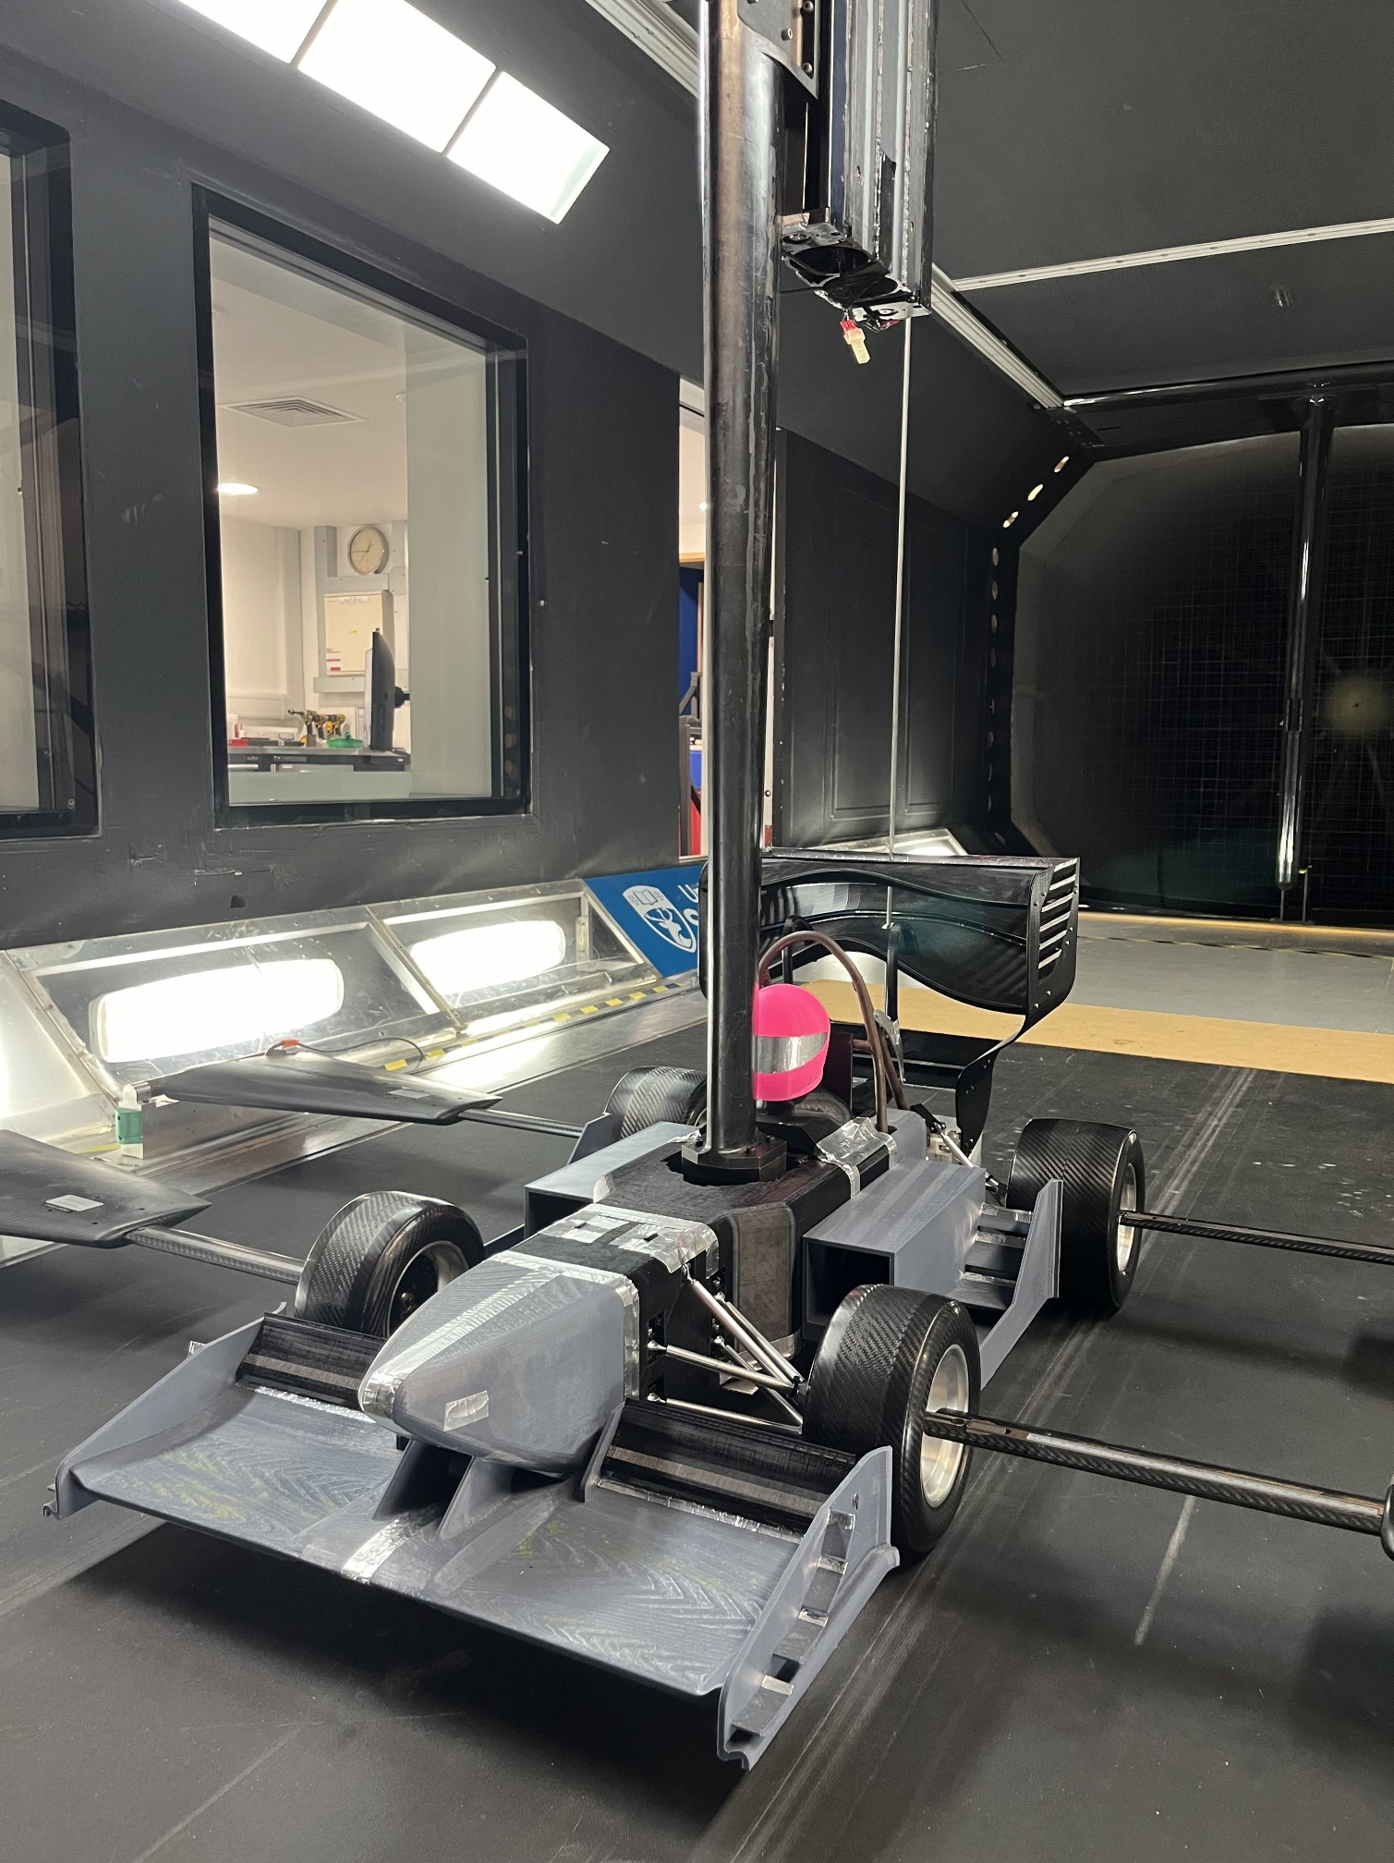


Design Report
FEEG6013 Group Design Project

15
Aerodynamics and model development of formula student car
The development of a modular aerodynamic package for a Formula Student car model suitable for wind tunnel testing

A legal, robust and modular aerodynamic package consisting of the front wing, sidepods and suspension system is designed for a 40% scale Formula Student battery electric vehicle (BEV) model operable in the R J Mitchell wind tunnel. Formula Student (FS) is an international engineering competition where student teams compete by developing, manufacturing, and racing a single-seater open-wheeled race car. Drawing inspiration from last year’s model, the aerodynamic components commenced from a minimalistic design and gradually matured across numerous iterations through systematic progression. The advancements are supported by computational fluid dynamics (CFD) and finite element analysis (FEA) evidence, where room for improvement can be easily identified. The performance of the scaled-down final design is verified in the wind tunnel experiment while preserving Reynolds similarity, an important metric. Regarding sustainability, the car model has been retrofitted using some parts from the previous year such as the rear wing, metal chassis and roll hoop to minimise waste. The majority of the aerodynamic package and bodywork are additively manufactured using fused deposition modelling (FDM), where PETG is the favoured material relying on its chemical and impact resistance and recyclability.

Eventually, the project achieved its performance targets (downforce, drag, efficiency and lap time) as initially set in the aims and objectives. Moreover, the car can adequately cool itself to perform to a high standard in the endurance event. The suspension system is also a remarkable feat of engineering and performed optimally during the testing. This project can serve as a guidance framework for potential stakeholders such as other Formula Student teams or wind tunnel users.

Group Members:

ID Number Name ID Number Name
31913962 Arjun Sidhu 31942938 James Clay
31426417 Arsha Ahmed Ahlam 32120494 Yong Hua Tang
31311458 Ian Lim Yi Hern

Primary Supervisor: Dr Zhiwei Hu Co-Supervisor: Dr David Marshall

Submitted on: 9th May 2024 (Thursday)

Table of Contents
Acknowledgements 1
Background 2
Stakeholders 4
Design Brief 4
Battery considerations 5
Cooling Modelling 5
Lap Time Simulations 6
Concept Evaluation 7
CFD Creation 8
Design Process 10
Front Wing 11
Sidepods 13
Suspension 16
Bodywork 17
Whole Car final design 18
Wind Tunnel Model Manufacturing 19
Wind Tunnel Testing 23
Validation (CFD and Model) 25
Final Design Proposal 27
GDP Review 28
Future Works 29
Conclusion 30
References 30
Appendix i
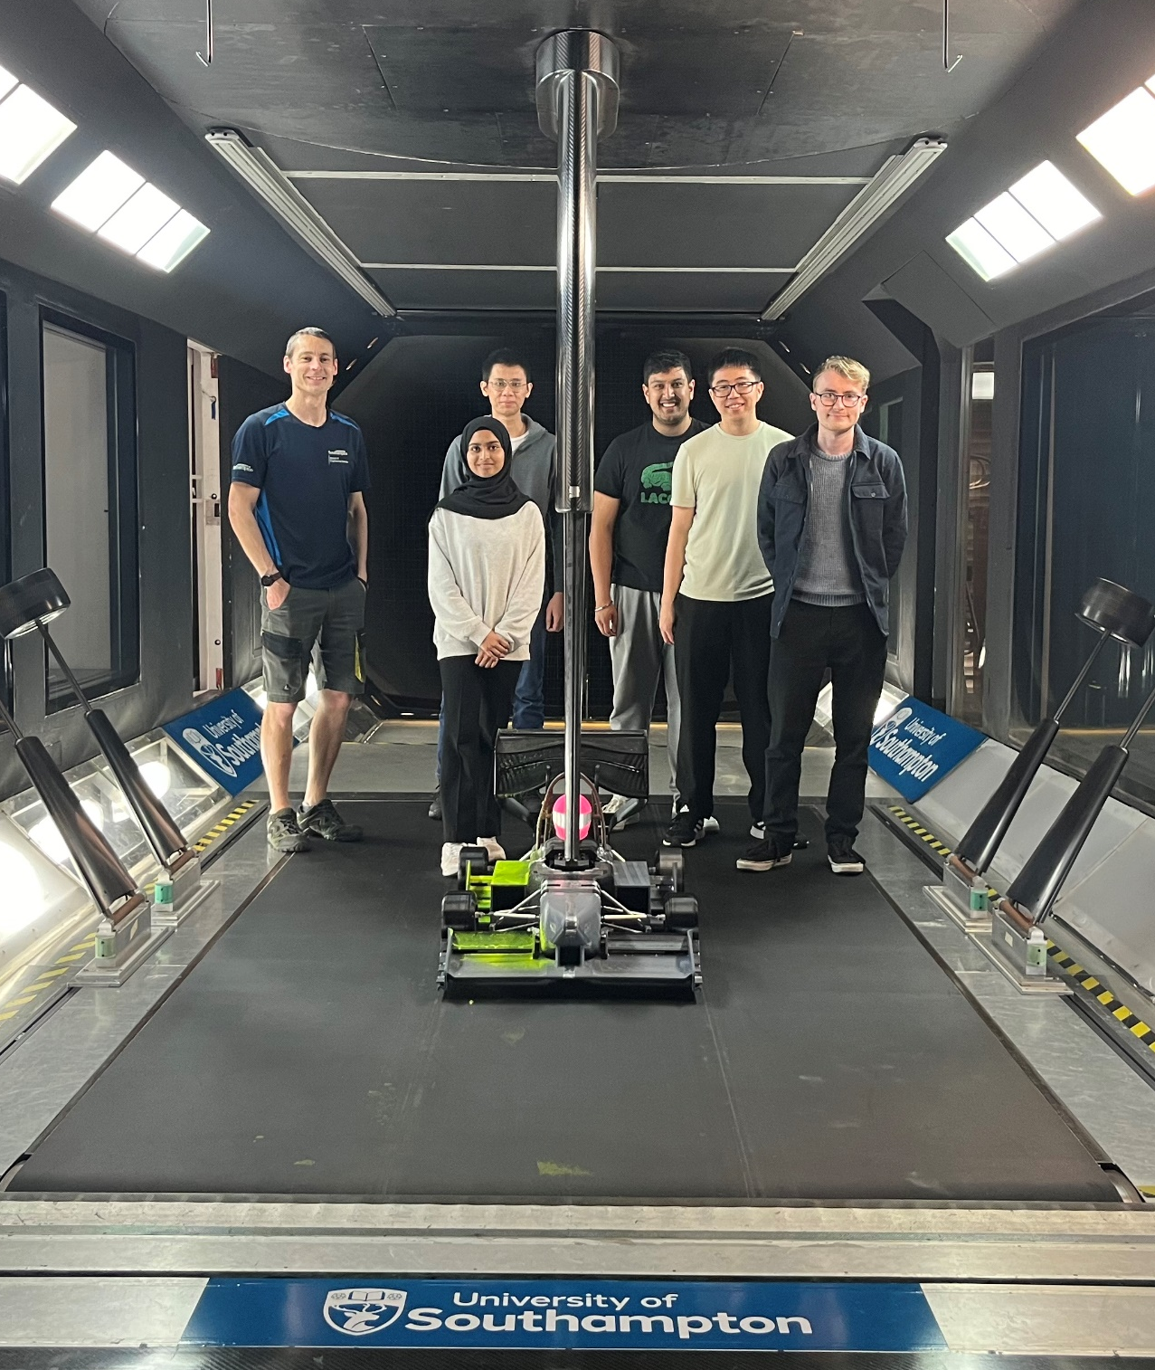

Acknowledgements
Firstly, we would like to thank our supervisors Dr Zhiwei Hu and Dr David Marshall for their invaluable guidance, constructive feedback and steadfast support throughout the project. We would also like to express our gratitude to our examiner, Prof Edward Richardson, for his constructive criticism and feedback which have significantly elevated the quality of the project. Special thanks to Dr Renan Soares for his guidance with the wind tunnel 3D printing facility and his assistance and support throughout the wind tunnel testing. Thank you to EDMC services for their hard work in manufacturing the suspension system. We also want to acknowledge the IRIDIS HPC facility of University of Southampton which assisted us with the CFD simulations.

Background

Formula Student
A 27-year-old event, Formula Student (FS) is an engineering competition in which student teams from around the world compete by designing, developing, manufacturing, and racing a single-seater open-wheeled formula race car. This car can be part of one of three classes: internal combustion engine (ICE), battery electric vehicle (BEV) or hybrid. [1]
With the global concern over emissions, there has been a large rise in the number in the number of BEV entries into FS [2] including the Southampton University Formula Student Team (SUFST). It is for this reason that last year’s project chose to design a BEV car and why this has continued to be the powertrain of choice.

Events
FS is comprised of 2 types of events: static and dynamic. Static events are those which the car itself does not run but instead are a chance for the teams to demonstrate the work they did to create the car from initial design to running on track. This project only focusses on building a wind tunnel model, not for Formula Student racing, so these events do not matter in the context of this project.
Dynamic events are where the performance of the car is measured, and this is the part which is key to this project. The dynamic events are acceleration, skidpan, autocross, and endurance. The endurance event also has an additional efficiency event contribution meaning that the maximum points gained from endurance are more than the points of the other dynamic events combined (350 against 250). [3]
Last year, the aerodynamic package developed was very effective at achieving raw performance. However, the lack of any cooling means that the car would have suffered in the endurance and efficiency events which, as discussed previously are worth more points and should therefore be a higher priority.

Aerodynamic Development
Aerodynamics are a crucial part of performance for any race car and especially open wheel formula cars. Downforce increases cornering performance because the increase in force acting downwards increases the total traction of the tyres.
For BEV cars, it is not necessarily always beneficial to produce as much downforce as possible. This is because batteries are nowhere near as energy dense as fossil fuels per unit mass. Therefore, for any car of the same weight, the amount of energy stored and subsequently, distance available, will be lower. The easiest way to increase the distance that the car can travel on a single charge is by reducing drag. However, removing all downforce generating components will greatly reduce the cornering performance of the car so the key to achieving optimal results is to find a compromise between these 2 problems which leads to striving for a high L/D efficiency.
Given a fixed distance, the average speed of a car determines the time it takes to complete a circuit. However, over a closed circuit, it is the change of velocity, i.e., acceleration, which is the deciding factor in determining the speed performance of the car. A race car's braking, accelerating, and cornering performance are the limiting factors in deciding a car's performance. Equation 1 [4] illustrates how this lateral acceleration can be determined over a fixed circuit and equation 2 simplifies this:
$Lateral Acceleration = μ×\left(g+\frac{downforce}{mass}\right)$ Equation 1
$Lateral Acceleration ∝ \left(\frac{downforce}{mass}\right)$ Equation 2
These show how the cornering ability is determined both by the mass and downforce of the car. Reducing the weight of the car is an extremely difficult task although there is no minimum weight limit in formula student. The easiest way to reduce weight is by having less batteries and the easiest way to do that is by having a more efficient aerodynamic package. Therefore, aerodynamics is crucial to achieving more lap time as they greatly help increase lateral acceleration.
A great way to create an efficient aerodynamic package is using ground effect. Unlike overbody aerodynamics (wings and other aerofoils), the ground effect phenomena generate downforce using the venturi effect to create regions of low pressure between the car and the ground. These produce large quantities of downforce with very little drag penalty. It is the concept now used by modern F1 due to the efficient downforce production.
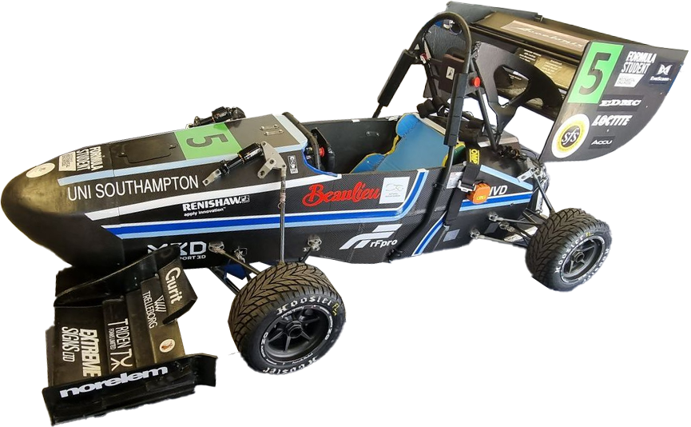
Figure 1: Stag 8 made by SUFST.

2022-23 GDP model
Figure 2 is an image of last year’s aerodynamic design. As mentioned previously, it was an extremely good design when it comes to aerodynamic performance. This year our aim will be to keep the performance at the same level whilst extracting more performance from other areas such as reliability.
The 2023 GDP group manufactured a 40% scale model of their final aerodynamic design to be tested in the wind tunnel to verify their CFD results, and an image of their car can be seen in figure 2 below. The main problem was that the suspension was provided from a previous project and when tested, it failed on multiple occasions and introduced a systemic error to the results as it applied a load to the balance which was incorrectly interpreted by the system as downforce.
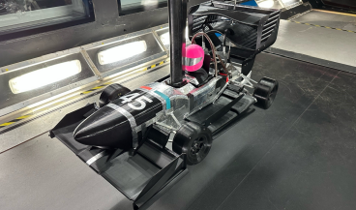
Figure 2: 2022-23 GDP 40% scale model.

Performance Evaluation
To evaluate the aerodynamic performance of a race car there are 3 main methods: computational fluid dynamics (CFD) testing, wind tunnel (WT) testing and track testing. Each of these methods have benefits and drawbacks. The undeniable best method for determining performance is track testing. Nothing is better than directly assessing how well the car will perform on track than by testing it on a track. The only problem with this is that you need a fully assembled, full scale and functional car to be able to complete this testing as well as a track to run it on.
This is where wind tunnel and CFD testing come into play. CFD is the quickest and cheapest way to assess performance. The speed of CFD allows for testing of a large quantity of design concepts in a short time frame. It also can be the best tool when it comes to visualising flow structures and understanding what the flow might be doing at any given point in space or time. The main drawback of CFD is the trustworthiness of results. CFD must be validated against some amount of real-world data to be able to use the results it generates.
This is where wind tunnel testing is useful. It works as a midpoint between track testing and CFD. It allows for real world testing of the aerodynamics without having to manufacture a full scale, operational car. The results from WT testing can be used to validate CFD results. WT testing being able to use a scale model car also means that costs and manufacturing time can be reduced between tests allowing for more designs to be validated using real world flow instead of if only track testing was used.
Once the data from these tests are acquired, some sort of lap time simulation needs to be conducted to assess how the aerodynamic performance will affect the speed of the car. The best way to do this is by use of simple programs which use equations such as equation 1 to determine the lap time of the car over a given track. This is not perfect as it does not directly account for how a driver may impact the performance of the car and there will be many simplifications and assumptions in the lap time model.

Current Wind Tunnel Testing
At the University of Southampton, there are two WTs; the RJ Mitchell and the 7’ x 5’ available for students and SUFST to use for projects and designs. The RJ Mitchell has a working section of 3.5 m x 2.4 m x 10.5 m, allowing for a maximum wind and ground velocity of up to 40 m/s, and a balance system with in-built pitch and yaw actuation [5]. The 7’ x 5’ tunnel has a working section of 2.1 m x 1.5 m x 4.4 m, allowing for a maximum ground speed and wind speed of 30 m/s and 45 m/s, respectively [6]. Of these two tunnels, the RJ Mitchell is the one used most by SUFST due to the in-built actuation system for their testing as well as the higher rolling floor velocity.
In the past, SUFST has performed both full-scale and 40% scale model WT testing. Both methods have trade-offs to consider. Full scale WT testing produces a large logistical and planning challenge to coordinate the full-scale car to the WT test section. The advantage of testing the full-scale car is that it allows for the geometry to be exactly matched to the actual race car, and the Reynolds number is maintained. The trade-off is the resources involved. The time spent WT testing the whole car could better spent in other areas, such as track testing, testing on a suspension rig or testing on a dynamometer. Due to size constraints, there is a limited actuation flexibility of the car, as a static full-sized car cannot perform the necessary ride height, pitch, roll and yaw conditions. Likewise, the full car can only be tested with static wheels, which results in fundamental changes to the flow and performance evaluation accuracy, in addition to the flow changes that occur from such a large blockage in the test section. Testing with rolling wheels involves suspension of the whole car in the wind tunnel, this is a significant increase in complexity for set up and is more costly. Figure 3 is an image of STAG VI in the RJ Mitchell wind tunnel.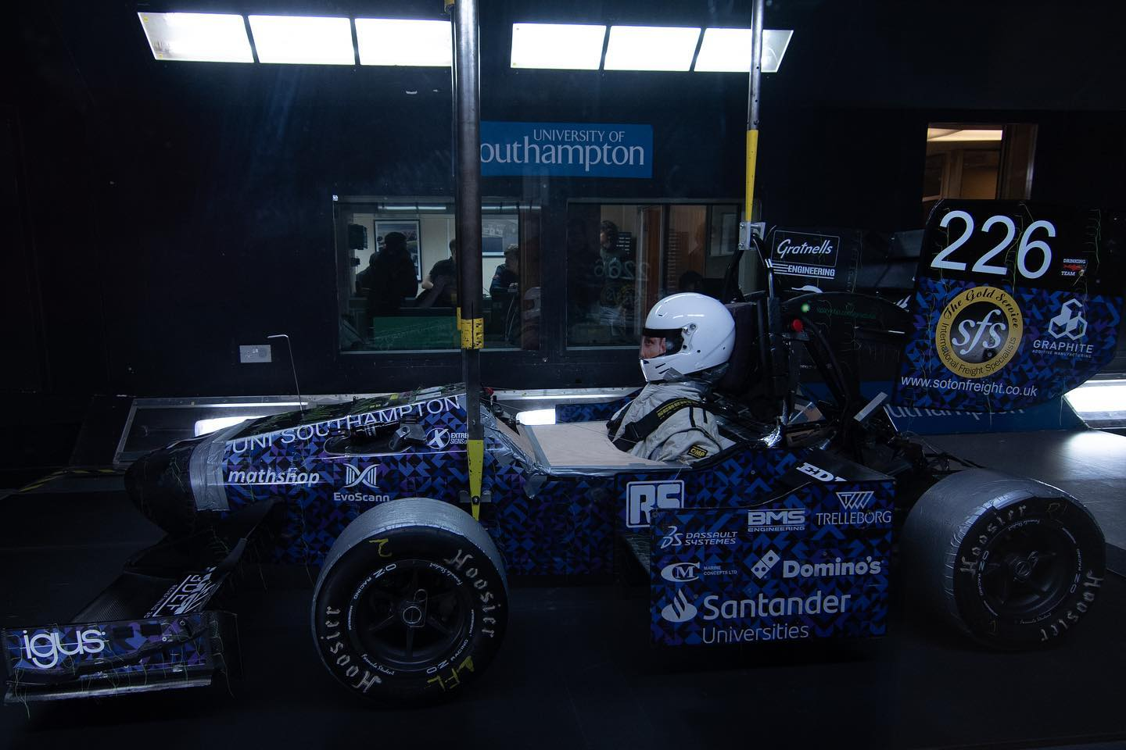
Figure 3: Stag 5 in the RJ Mitchell Wind Tunnel.

Stakeholders

Direct Stakeholders
The direct stakeholder in this project is the Faculty of Engineering and the Environment at the University of Southampton. Within the MSc Race Car Aerodynamics course, the group design project focuses on developing the aerodynamics package for a Formula Student (FS) car through computational fluid dynamics (CFD) validation. This project could serve as a valuable resource for assisting students in their validation efforts in the future. Using a validation tool is not typical in projects of this nature, presenting an excellent learning opportunity for the students involved. They would gain hands-on experience in wind tunnel (WT) testing, validation techniques, and rapid prototyping technology, enhancing their project outcomes. The approach of employing the model for validation could also be extended to other group design projects within the MEng programme and individual projects within the BEng programme. Incorporating a readily available WT model would facilitate more comprehensive aerodynamic design, testing, CFD simulations, and FS projects. Additionally, the faculty stands to benefit from integrating the WT model into design shows and open days, leveraging it as an advertising tool to attract prospective students by showcasing ongoing projects and research initiatives.

Indirect Stakeholders
The Southampton University Formula Student Team (SUFST) serves as an indirect stakeholder in this project. The team stands to gain from having a model for conducting physical testing to assess any aerodynamic concepts they generate. Previously, they utilised a Wind Tunnel (WT) model for CFD validation, but this model has fallen into disrepair. Presently, they are in the process of creating their own 50% model, although it remains incomplete and thus this model can be utilised temporarily. Historically, the team employed full-scale WT testing for model validation, but this approach introduces numerous errors due to fundamental differences in the validation process. Blockage effects become more pronounced, and the absence of rotating wheels suggests that validation may not be representative and may not correlate effectively.
Integration of a WT model would complement SUFST's design methodology and provide a valuable learning opportunity, aligning with the academic curriculum for students. As the team transitions their racer to a Battery Electric Vehicle (BEV), developing an aerodynamics package tailored to a BEV configuration would greatly interest them. Additional indirect stakeholders may include external parties such as school and college students, who could utilise the WT model for learning about aerodynamic development or for their own projects. This could potentially serve as a revenue stream for model utilisation.

Design Brief

Project Aim
The aim for this project is to improve the performance and reliability of an aerodynamic model of a FS car with an electric powertrain. To validate the success of this design, the previous wind tunnel model on which aerodynamic concepts can be tested will be made more reliable. To meet the stakeholders’ needs, the design of the WT model must continue to be usable in the RJ Mitchell Wind Tunnel and have an element of modularity with the key aerodynamic components typically found on a FS car, such as the front wing, mid car elements, rear wing, and underfloor. The suspension should also allow for both wheels on and wheels off testing with ease. For further validation, the development of this aero package will be done using a CFD workflow which will include further validation scenarios including simulations of yaw and pitch. This aim will be achieved via the following objectives:

Aerodynamic Design Objectives
- The 2024 FS regulations must be studied, and the model updated to be legal if necessary.​
- The trajectory of the aerodynamic design will be targeted towards increasing cooling capacity.
- A successful design will adequately cool the batteries whilst keeping similar aerodynamic performance to the previous model.​
- Structural considerations need to be kept in mind whilst designing to ensure designs are feasible, manufacturable, and testable.
- The new suspension design must be considered when designing the new aerodynamic package.
- The new aero package must be within 90 % of the lift and drag values of the previous design and within 0.5 s per lap.

Simulation Workflow Objectives​
- The lap simulations need to be refined to fully account for the BEV powertrain not ICE.​
- FEA and CFD must be used throughout the design process to rigorously test components before manufacture.​
- New CFD validation scenarios should be developed to help with wind tunnel correlation. These should include roll, pitch, and yaw scenarios.​
- The tool must be modular in the sense that parts can be swapped with ease to allow for rapid design iterations.
- The domain must be interchangeable to work with other wind tunnels not just R.J. Mitchell.
- Comprehensive post processing is needed to understand the complex flow structures that arise from race-car design.

Wind Tunnel Model Objectives​
- The suspension in the model must be robust enough to withstand the forces from wind tunnel testing.​
- The tyres and suspension should allow for easy switching between wheels on and wheels off testing.​
- The model must be repeatable to ensure confidence in the results.
- The model must be modular such that all components can be replaced and improved upon by more mature designs.
- ​ The tool must be modular in the sense that parts can be swapped with ease to allow for rapid design iterations.
- The domain must be interchangeable to work with other wind tunnels not just R.J. Mitchell.
- Comprehensive post processing is needed to understand the complex flow structures that arise from race-car design.

Battery considerations

Introduction
The creation of a drivetrain is out of the scope of this project. However, the consideration of this element of the car is important as it will impact the overall design of the aerodynamics and the bodywork. It will also impact our calculation of lap times for analysis.
Last year’s team did an in-depth analysis of the battery package. It was important to have a key understanding of this information to design the cooling package.

Important considerations
Designing and optimizing a battery module plays a pivotal role in enhancing car performance. The battery pack must adhere to power, weight, and size constraints due to the car's spine and bodywork design. It's imperative that the battery pack is electrically, mechanically, and thermally integrated to deliver power safely and efficiently. Efficient packing of battery cells is essential to minimize weight and size while maintaining mechanical integrity to reduce material usage and unnecessary weight, ensuring structural integrity and crash protection. The Battery Management System continuously monitors cell temperature, discharge rate, and voltages.
Mechanical configurations and stability guidelines, as outlined by the FS UK Rules [3] and achievable through ANSYS Simulation and analysis, must be meticulously followed for the battery pack module and integration to achieve peak endurance and efficiency. The durability of lithium cells is significantly influenced by factors such as current draw, charge and discharge rates, and operating temperature. Extreme temperatures, especially high temperatures during fast charging under high current loading conditions, have a profound impact on battery performance.
In accordance with Formula Student regulations regarding battery packs, the peak power output should not exceed 80 kW. Each accumulator segment must adhere to voltage, energy, and mass limits of 120 V, 6 MJ, and 12 kg, respectively [3].

Battery Overheating
The driving characteristics of a BEV are completely different to that of an ICE car. Over an extended distance, ICE cars have a constant power output as opposed to BEVs where their power output decreases over time. The power output decrease of the BEV can be attributed to a multitude of factors, namely, SOC and battery temperature. In high performance events such as Formula E, battery warm-up is always done before the start of the race so that cars will be able to commence the race at peak power levels. However, this decreases over the duration of the race and is affected by driving style and the battery management system. Figure 4 shows the SOC and battery temperature over the duration of a Formula-E race employed in the car’s battery management system omitting regeneration [8].
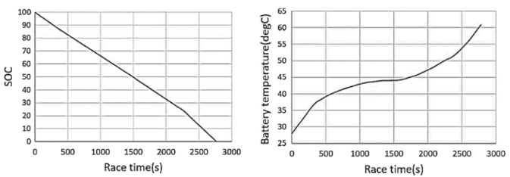
Figure 4: Effect of battery temperature in Formula E [8].
It can be clearly seen that over the duration of the race, battery temperature increases over race distance. Furthermore, the drop off in SOC is much steeper after 2250 s. This is a result of the battery temperature increasing over 50 °C, at the same time resulting in more energy consumption. Currently, Formula E teams utilise various deployment profiles to generate optimal energy allowing for a comprehensive strategy over a stint [9]. Drivers will also have to adjust their driving style to ensure reliability. Employing a more aggressive strategy will need the driver to lift/coast more frequently towards the latter stages of the race as opposed to a more conservative approach managing their driving style and being aggressive when necessary. This technique is common for energy management during a race [8]. Thus, this is a significant factor that engineers and drivers consider both before and during the race to avoid any potential DNFs.

Endurance Event
In FS, there are 4 dynamic events: acceleration, autocross, skidpan, endurance. The first 3 are worth 250 points which is the same amount as the single endurance event. There is a bonus 100-point efficiency event linked to the endurance event. Therefore, the most effective way to maximise points in the competition is to optimise for the endurance race.
The race is 22 km long and in 2023 only 8 out of 19 cars finished the race. The endurance points system rewards finishing the race above speed anyway so there is such a large opportunity to gain by maximising the design for this event. If the car fails to finish the race, the number of points it is eligible to score is limited to 10% of the maximum points available for the event which in this case is 25.
Last year’s group conducted a small investigation into the benefit of adding a cooling system for the battery and the result of this is shown in figure below.
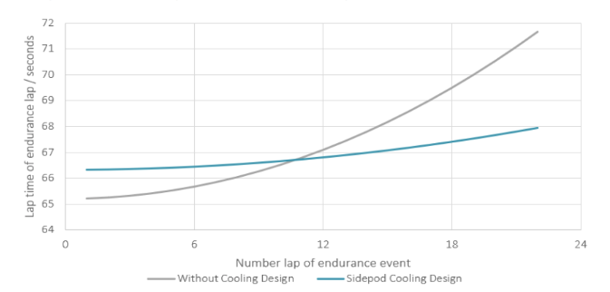
Figure 5: Comparison of the effect of cooling over the endurance event.
Even with minimal effort dedicated, the introduction of a radiator and cooling system to the car will greatly increase the speed of the car in the later stages of the event. The total race time was 12 seconds faster than without any cooling.
One issue is that their cooling design did not model radiators in CFD so the data may not be truly accurate as well as the fact there was very little analysis conducted into the cooling effect the sidepod would have on the car and whether their sidepod design would be sufficient.
The main reason cooling was not investigated further was the impact it had on aerodynamic efficiency. In last year’s report, the drop in L/D was quoted to be from 4.001 to 2.925 and this will be the main challenge for our sidepod design; to recover a lot of this loss.

Cooling Modelling
The next step was to create a theoretical model for the cooling system of the car. This was done so that the radiator size needed to successfully achieve our cooling goals could be obtained. A popular cooling system employed by FS teams running BEVs is a single loop cooling system as it is relatively simple in design and lightweight [12].
An opensource MATLAB script was found which models this type of cooling design [12], and it was taken and adapted to fit our car. It uses the NTU method of heat transfer to model the heat lost to the air as a function of flow rate, airspeed through the radiator, ambient temperature, water inlet temperature, and radiator size.
The first piece of information to gather was the velocity of the air entering the inlet. From CFD, it was found that the velocity of the air entering the cooling system was approximately 85% of that of the freestream velocity and this did not vary as a freestream velocity changed. The heat transfer coefficient was assumed to be approximately the same as the one provided by the author. This provided the following plot of cooling capacity.
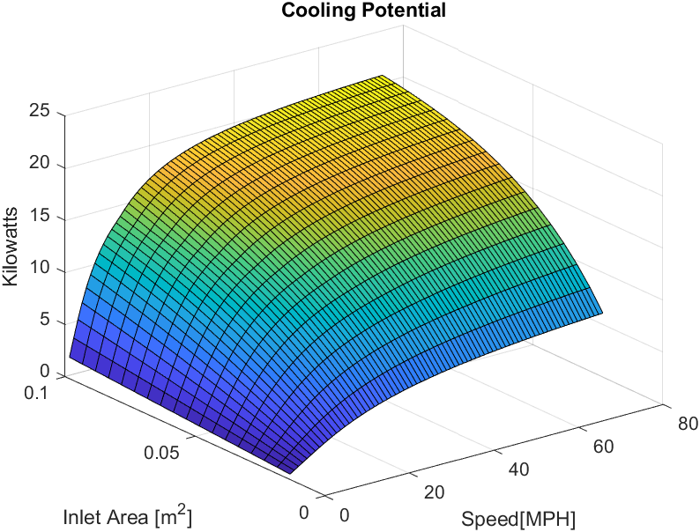
Figure 6: Cooling capacity generated plot.
The other plot that the script created was the cooling load generated by the motor and battery unit. This was done with a generous assumption that all the inefficiencies in the motor and motor controller are cooling load. A value for the heat added into the system was found based on the current torque and rpm of the motor. There was also a built-in factor of safety of 1.5 to account for the many unpredictable variables and this variable was kept at this value.
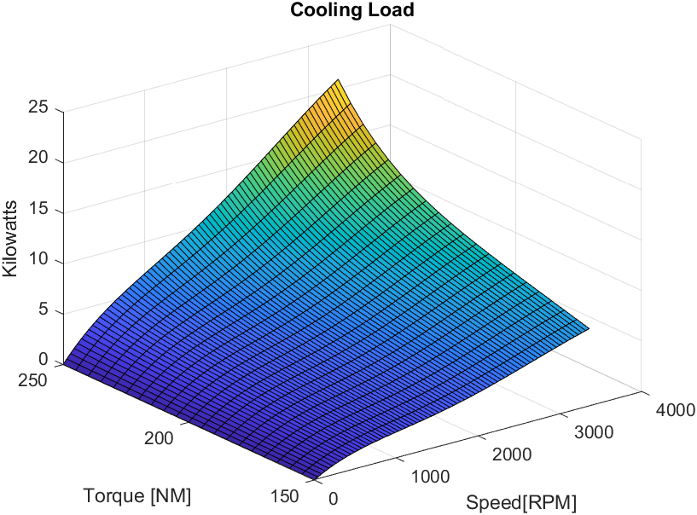
Figure 7: Cooling load generated by the motor.
From this it was clear that the cooling load would be somewhere in the vicinity of 10 kW. This meant that from the cooling plot it could be seen what the ideal radiator size would be. It was decided a size of 0.05 m was ideal as this gave a cooling of 10 kW once the car was above 20 mph which is very low speed for this type of car.
However, upon browsing for radiators, a radiator from Kuehler Rath that was quoted as being suitable for BEV formula student was discovered. The radiator measures 195 mm x 178 mm which is slightly above what was wanted but it was decided that for now it would be a good initial test that and it could change if the data suggested it was needed to.
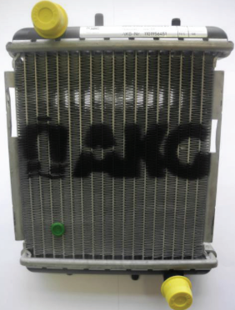
Figure 8: Radiator that would be used for the full scale model.
After this, the script was once again used this time in conjunction with lap simulation data (see next section) to see how the car would be cooled over a race distance. For this, an ambient temperature of 35 °C was assumed. Figure shows the temperature of the coolant on the final lap of the race.
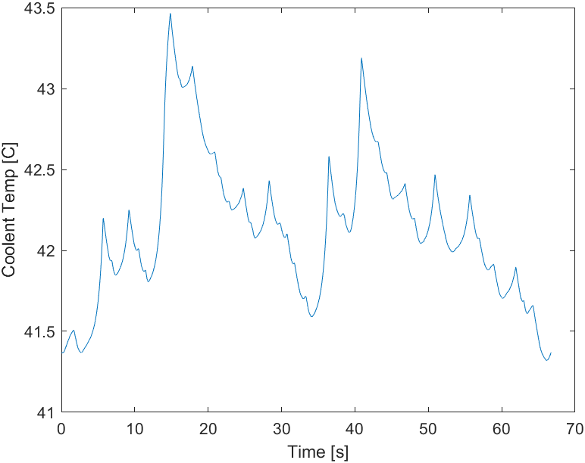
Figure 9: Temperature of the coolant on the final lap of the endurance event.
This shows that the car has adequate cooling available to keep the car below 50 °C with the radiator found. There is also margin for error which is good as there are many modelling assumptions made but none of these should have an impact.

Lap Time Simulations
To aid in both the analysis of the aerodynamic performance data as well as the cooling modelling, a lap time simulator needed to be used. An open source one was found and adapted for our use [11]. Over the course of the project, this lap simulator was used as a quick way to quantify performance enhancements. The track design, and the outputs of the simulator are presented below in Figure 62.
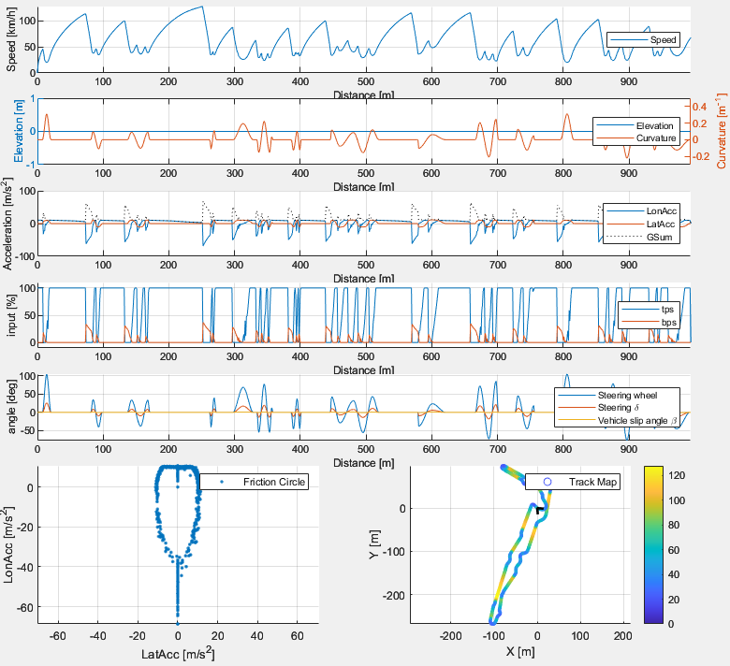
Figure 10: OpenLAP lapsim output.
The simulator is designed for use with an ICE powered car not a BEV. However, the car data was inputted by assuming a 100% efficient gearbox with only 1 gear (BEVs do not require gearboxes) and the torque curve was simply replaced with one that would be standard for a BEV. The software clearly does struggle with some pure longitudinal acceleration scenarios due to the instant torque nature of the powertrain however the lap time output was 69.091 s which is within the range of lap times from the 2023 autocross event.

Concept Evaluation
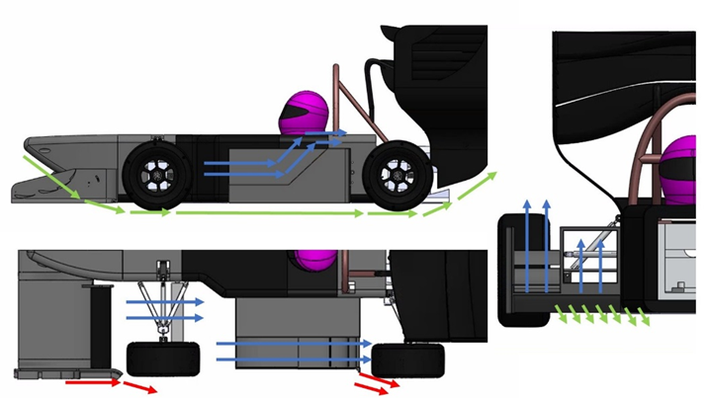
Figure 11: Flow field concept.

Front Aerodynamic Flow Design
At the front of the car, the key aerodynamic components include the nose and the front wing. The front of the car effectively sets up the flow for all the downstream components, and so the wake it leaves determines the aerodynamic performance of the whole car. The front wing should be designed to promote outwash of the front tyre wake, which is what the red streamline depicts. The red lines represent vortices which will be used to generate this outwashing effect this is done because the front wheels contribute a large amount of the total drag of the race car. Due to the rotation of the front wheels, there is a large separated flow region in their wake which negatively impacts the downstream components. Understanding and controlling flow around the front wheels allows for reduced drag and increased performance for the aerodynamic components downstream. The blue streamlines depict flow designed to minimise tyre squirt losses. Acting between the front wheel and the chassis, the tyre-squirt losses occur because of tyre compression and the contact patch between the tyre and the ground. This region of low velocity flow generated enters the underfloor, reducing its efficiency and is detrimental to the general performance of the middle of the car. The green streamlines depict the flow used to generate downforce through ground effect. The idea behind this is to maximise the mass flow of the air at the inlet to the floor, to maximise ground effect through a diffuser. Maximising the area at the inlet increases the mass flow through the underfloor which, for a fixed underfloor volume, increases the overall downforce of the car due to ground effect.

Mid Car Aerodynamic Design
The middle of the car has 2 jobs: generating downforce and cooling the batteries. The blue streamlines depict this flow. The upstream sections show how the inlet of the sidepod will be fed inboard air from the front wing. This is done because the wake of the front wing is very low energy air that is traveling at a slower velocity to the rest of the car. This means that the radiator will have more time to transfer heat from the cooling system to the surrounding flow.
The outboard section of the mid car is used as a downforce generating area. It is unfortunately positioned behind the front tyres which as discussed previously, are a part that generates large amount of turbulent air. Ideally, this part would be positioned elsewhere however this is simply impossible. The aerofoils at the rear of this section will help generate an upwash effect which will reduce the energy of the flow approaching the rear tyres, reducing drag, and increasing downforce as tyres are a draggy, lift generating component.

Rear Aerodynamic Flow Design
The green streamlines in this area represent the path of flow through the diffuser and underfloor. The main goal of the diffuser is to cleanly extract the flow from under the car. The cleaner this can be done for a given expansion ratio will aid generating suction under the floor of the car. This doesn’t just stop at the geometric boundaries of the diffuser. The diffuser will become even more efficient if the virtual expansion surface continues behind the car, which is extended by a beam wing. The rear wing needs to be kept in a flow that is as close to freestream conditions as possible. This will allow for maximum performance. The main way to achieve this is by considering the wake effects of the driver head and roll hoop and designing the rear wing around those geometries.

CFD Creation

CFD method
The previous year’s CFD model encountered issues during both meshing and solver execution, rendering it unusable. Consequently, a new CFD solution was imperative. Utilizing Star-CCM+, the CFD simulations were conducted leveraging the IRIDIS high performance computing (HPC) facility.
In Star-CCM+, various automatic mesh generation models are available to produce the necessary volumetric mesh for domain modelling. The three primary options are trimmed cell, polyhedral, and tetrahedral meshes. While the tetrahedral mesh offers the least computational expense, its suitability for the intricate geometries and bodies of this project is limited. Both polyhedral and trimmed cell meshes were evaluated for the baseline mesh, with both yielding accurate flow results. The trimmed cell mesh, aligning with the flow direction, is typically preferred for wind tunnel validation, whereas the polyhedral mesh, with marginally reduced computational time, is favoured for rapid iterations, provided the geometry input lacks errors. In this instance, the polyhedral mesher was chosen due to the complex car geometry and its capacity to reduce computation time.
Regarding turbulence models, options included the k-ɛ model, k-ω model, or the Spalart-Allmaras (SA) model. The k-ω model was selected for its ability to precisely predict flow properties in near-wall regions, making it more suitable for high shear and adverse pressure gradient conditions compared to the k-ɛ model. Moreover, it provides more reliable predictions in cases of boundary separation compared to the SA model, making it the optimal choice for this project.
Reynolds Averaged Navier-Stokes (RANS) turbulence models are commonly employed for resolving flow fields within engineering contexts due to their stability and fast convergence. [10] The k–ω turbulence model was retained from the previous year's simulations due to its accurate resolution of near-wall flow. While other options such as the SA model and the k-ε model were considered, the k–ω model emerged as the preferred choice due to its efficacy in resolving turbulent flow conditions and its suitability for this project's requirements.
The k–ω model, like the k-ε model, predicts turbulence based on turbulent kinetic energy, but it also effectively models low Reynolds number effects, making it suitable for various flow conditions. The SST k–ω model, an advancement of the standard k–ω model, combines features of both k–ω and k-ε models, enhancing its accuracy and applicability across different Reynolds number ranges. Despite necessitating high near-wall mesh resolution, the SST k–ω model was chosen for its increased accuracy and suitability for the project's testing conditions.

Validation of CFD
The CFD simulation incorporated both the final design from the previous year and Stag 7. Ensuring confidence in the CFD workflow necessitated the meticulous design of a computationally efficient and accurate model, achieved through iterative refinement and testing. For the straight-line simulation setup, the domain was divided into two halves for a half-car simulation, reducing computational overhead by exploiting the car's symmetry with a symmetry plane.
The domain featured a velocity inlet of 13.4 m/s (30 mph) and a moving ground at the same speed, mirroring the average speed of a FSUK car during a sprint circuit event. Extending 10 m ahead and 25 m behind the point of origin, the simulation also simulated rotating wheels, spinning relative to the wheel's centre with a diameter of 450 mm, perpendicular to the flow direction, at a speed of 58.3 rad/s as that is how fast the wheels would be turning if the car was at that velocity. Figure 10 illustrates the boundary conditions and domain face setup for this simulation.
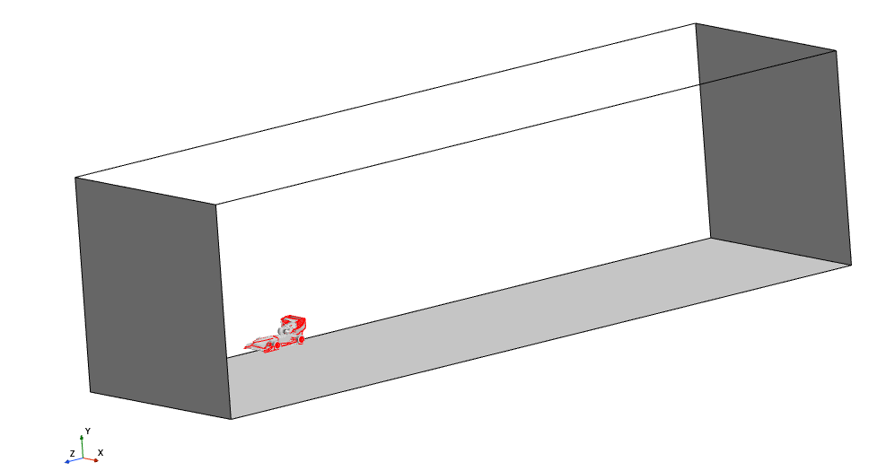
Inlet set to 30 mph

Rolling floor set to 30 mph
against freestream direction
Pressure outlet set to 0 pa
Figure 12: CFD domain setup.
Meshing aimed for an accurate baseline representation through a mesh independence study, enabling observation of flow interactions, vortices, and separation points. Ensuring correct modelling of the viscous sub-layer involved splitting the CAD into constituent surfaces for enhanced mesh refinement control. Surface mesh splits were categorized into aero-components, chassis, wheels, and suspension. Mesh parameters between components were globally linked, allowing for scaling during mesh independence testing, while near-wall mesh parameters remained fixed, ensuring consistency in boundary layer mesh design. Figure 11 outlines the split surface parts.
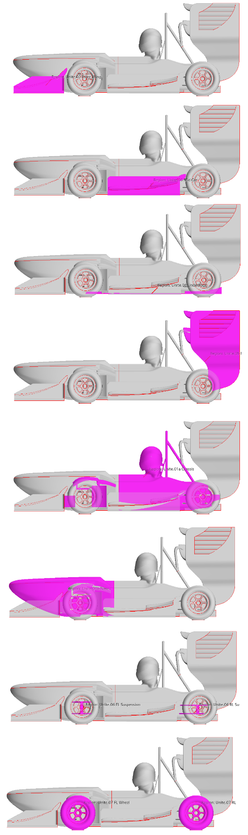
Figure 13: Image showing how the different mesh surfaces were split.
The volumetric mesh was divided into fixed volumes for density refinement, with high-resolution regions designated for aerodynamically critical areas and vortex-prone regions. This is shown in figure 13. Coarser refinement areas were allocated where reduced detail sufficed, notably around aerodynamic components, as depicted in figure 14. Wake refinement regions, representing less crucial flow structures, were meshed less densely than finer regions but denser than the overall domain, providing a smoother transition from the car's vicinity to the broader mesh, as shown in figure 15. Initial prism layer settings were informed by the previous year's model, refined through iterative adjustments and optimization.
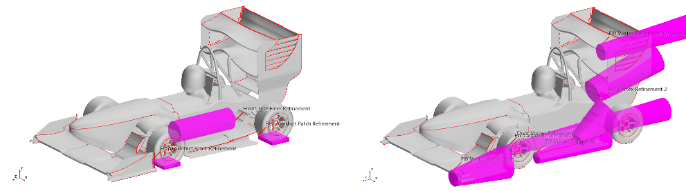
Figure 14: Fine vortex refinement.
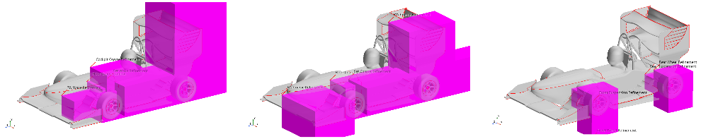
Figure 15: Close car refinement.
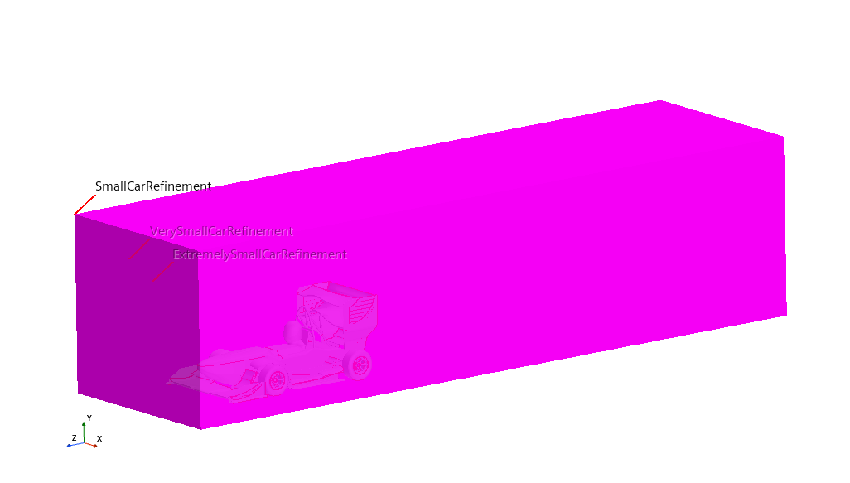
Figure 16: Coarse wake refinement region.

Initial Meshing and First Run
Now the solution was ready to mesh. The base size of the mesh generation was set to 0.03 m as this is what last year’s design used. This generated a mesh that was 53 million cells in size. This had a wall time of approximately 16 hours when using 120 cores of the HPC. The simulation was set to run for 4000 iterations before completing however, upon looking at the residual outputs, it was clear that the solution had converged far before 3000 iterations as is shown in figure 17 and so that was the new standard iteration count. This reduced the wall count from 16 hours down to 12, greatly saving on both time and energy throughout the project. 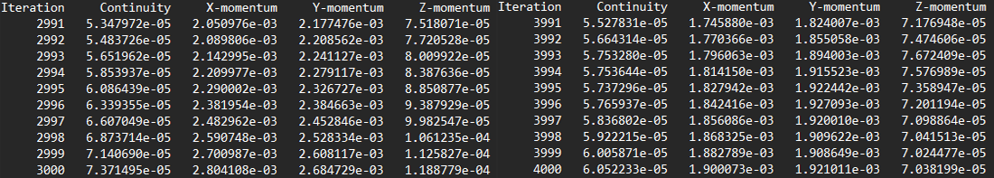
Figure 17: Residuals from CFD.
Last year’s group also provided no post processing script so one had to be created from scratch. The script created was capable of outputting slices for Coefficient of Pressure (C_{p}), Total Coefficient of Pressure (C_{p}T), Velocity and Vorticity. The script also output all the force measurements to a CSV file for data analysis. During data analysis, the force results were measured over the final 1000 iterations due to the nature of using a RANS solver for a non-steady state solution. There was also a 1-time use script created to check y1+ and the output of this can be seen in figure 18.
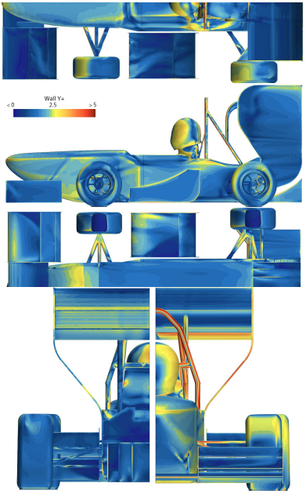
Figure 18: Wall y1+ surface plot.
In total, it took 52 iterations of trial, error, and refinement to get to this stage of the first successful run. However, after this the process of running new simulations would become much faster.

Mesh independence Study
Now that the initial meshing was complete, it was time to conduct a mesh independence study to gain confidence in the mesh density. The process of varying the mesh density was very simple, all that was required was editing the base size that was linked to all the volume mesh controllers. The relationship between base size and mesh cell count is shown in figure 19.
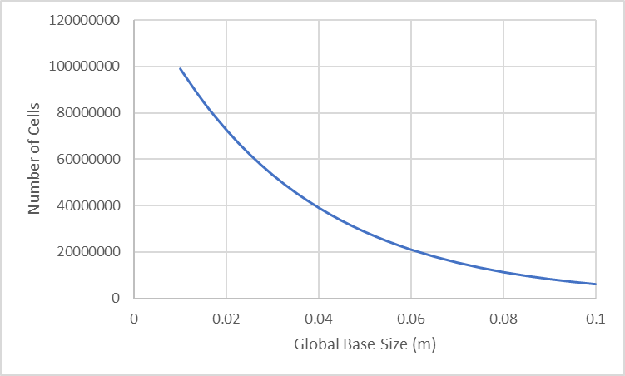
Figure 19: Relationship between global base size and number of cells.
Next it was time to compare how lift, drag and aerodynamic balance changed with cell count. These were chosen as they are the 3 metrics which there is reference data from last year. The relationship between SC_{L} and cell count is shown in figure 20. The prefix S denotes how the area has been normalised for both lift and drag. This is done so that in the future,

Figure 20: Relationship between cell count and lift.
It is important to remember that the values here will likely be higher than that of real life as the geometry is smoothed and simplified in a CFD environment which means less losses compared to the real car. The value appears to converge at around 50 million cells, but it converges at around 4.622 which is lower than our reference value of 5.045 and is an error of 8%. Next was the drag which is in figure 21.

Figure 21: Relationship between cell count and drag.
This time the value seems to converge much sooner than the lift coefficient did. However, once again the difference between our data and last year’s reference was high at an error of 28%.
The final test of last year’s car was the aerodynamic balance. This is shown in figure 22.

Figure 22: Relationship between cell count and aero balance.
This followed a very similar pattern to the lift coefficient and was also around 8% away from the reference value. This means there is a systematic error somewhere because if the balance is the same then it means that all the parts are wrong by that error margin not just a single part causing it.

Validation
There was a concerning difference between the reference data of last year and our simulation. It was made more difficult by the fact there was no access to the raw data from their CFD, only what was quoted in the report. The solution to solving this was to utilise the CAD of Stag 7 from SUFST. This is because it was a design where we had a data set which we could use as a reference which had been validated with wind tunnel testing and the errors when using that model are shown in table 1.
Table 1: .
Variable​​ | Reference​​ | CFD​​ | Error %​​
Stag 7 Lift (N)​​ | -158.589 ​​ | -139.894 ​​ | 11.7​​
Stag 7 Drag (N)​​ | 80.34708 ​​ | 81.22964 ​​ | 1.1​​
Stag 7 FR%​​ | 30.01179 ​​ | 29.86219 ​​ | 0.5​​
This was much more promising and the difference in lift appeared to be from a problem with how the tyres were set up between simulations as they were the only component that showed any signs of change between the 2 data sets.
This gave us much more confidence to proceed with our design and we hoped that the wind tunnel test could help us answer what happened between our data and last year’s.

Design Process

Initial Design development
The project aimed to build upon the 2022-23 GDP final model. The initial step in the design process involved identifying and deciding which parts of the FS car required improvement. This process began by examining the 2023 model and studying their group report. While deliberating on which components to redesign, importance was given to suggestions for future improvements by last year’s team. This included improving the cooling capacity and an improved suspension system. The cooling capacity is an important factor to improve efficiency of batteries and increase performance. This can be achieved by the addition of sidepods to the design. Therefore, the decision was made to prioritise the design of sidepods and completely redesign the suspension system.
The addition of a new cooling system would introduce aerodynamic losses in performance and so the rest of the design process would be centred on trying to recover those losses however possible.
To understand the car's aerodynamics, CFD analysis was conducted on the 2023 model. The results were carefully examined to gain insights into the aerodynamics of both the front and rear wings. It was evident that the rear wing was already optimized to a high degree, displaying significant aerodynamic efficiency. Therefore, the decision was made to focus on redesigning and improving the aerodynamic efficiency of the front wing, as it presented greater potential for enhancement. Another idea was that the implementation of an adjustable element to the front wing would allow for further validation of the wind tunnel data as it would allow us to create a more complete dataset.

FS UK 2024 REGULATIONS
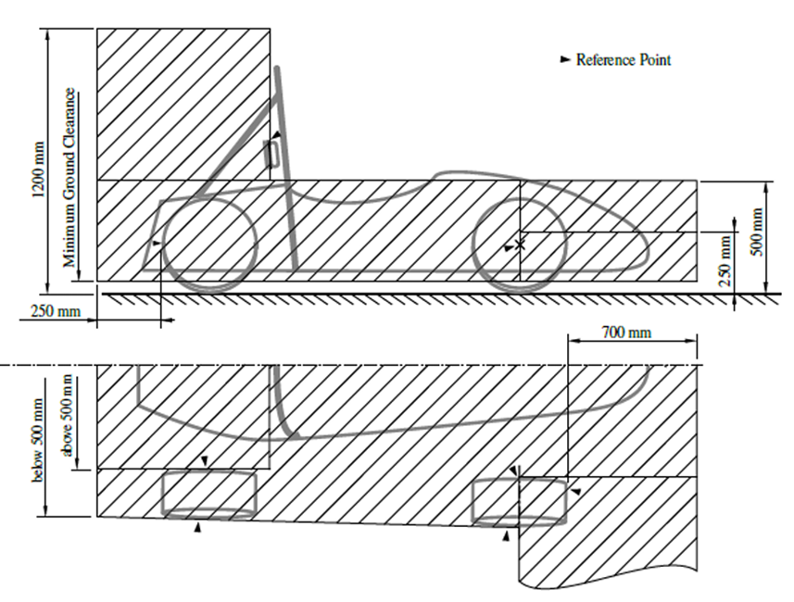
Figure 23: FS UK 2024 aerodynamic component dimensional restrictions.
The figure 23 shows the maximum dimensions and the positions of aerodynamic devices allowed by FS UK 2024 regulations. This was done after the suspension and wheel design was finalised since its position on the car determines the position of aerodynamic devices. The ‘aero legality’ box was created in SolidWorks around the chassis geometry according to the FS requirements. It was created with a 30mm ground clearance, starting from 350mm from the forward most point of the car and ending at 250mm from the rear wheel.
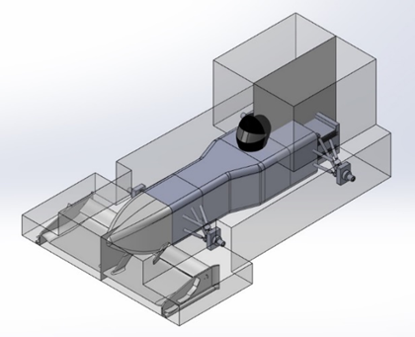
Figure 24: 'Aero legality box’ CAD.

Design process
The design process involved an iterative process for each part, the front wing, sidepods and suspension system. Several iterations were performed before the design was finalised, which aimed to refine and improve the performance of the components based on feedback and analysis. The process started with conceptualizing new ideas or modifications to the 2023 model. These concepts were then translated to CAD models using SolidWorks. FEA and CFD were then conduction to evaluate the structural and aerodynamic performance on each design iteration. Both these methods were used to analyse the potential areas for improvement. Once the problems were identified, adjustments were made to the design and the design cycle continued until the requirements were met. The iterative nature of the design process allowed for continuous improvement and optimization, ultimately resulting in a design with high aerodynamic performance.
Throughout the design process, iterative development of aerodynamic components such as the front wing, sidepods, and bodywork aimed to optimize performance and ensure compatibility between parts. Various whole car configurations were tested via CFD simulations to enhance downforce while minimizing drag, with attention given to integration and interaction between components for smooth airflow. CFD analysis provided insights into the individual performance of each component and how they collectively functioned as an integrated system.

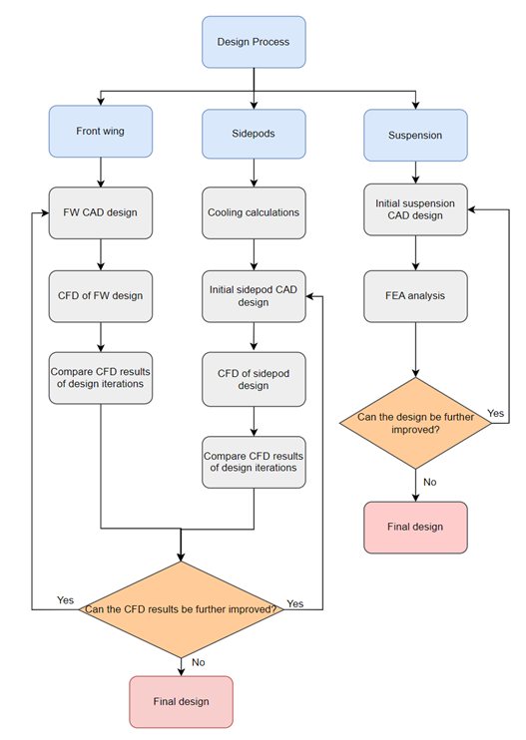
Figure 25: Design process flowchart.

Front Wing

Feature development
The primary function of the front wing is to optimise downforce production at the car front axle while simultaneously regulating airflow around the rest of the car, given its position as the initial point of contact with the incoming airflow. The distribution of downforce across the front wing significantly influences the aerodynamic balance, thereby impacting the car's overall handling dynamics. Therefore, it is crucial to create a design that focuses on maximising the downforce while directing airflow to disperse the turbulent wake away from the front wheels.

The front wing structure includes the aerofoil section and the endplates, mounted on both sides of the wing. The endplates serve crucial functions: firstly, they prevent the formation of trailing vortices at the wingtips, enhancing downforce by ensuring even pressure distribution in these areas. Secondly, they create an outwash flow to steer airflow away from the front tyres, reducing tire-generated drag.

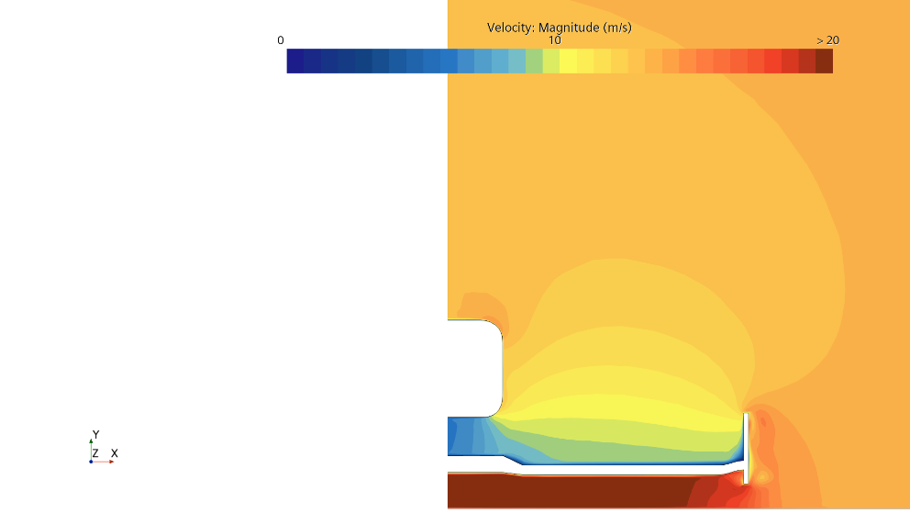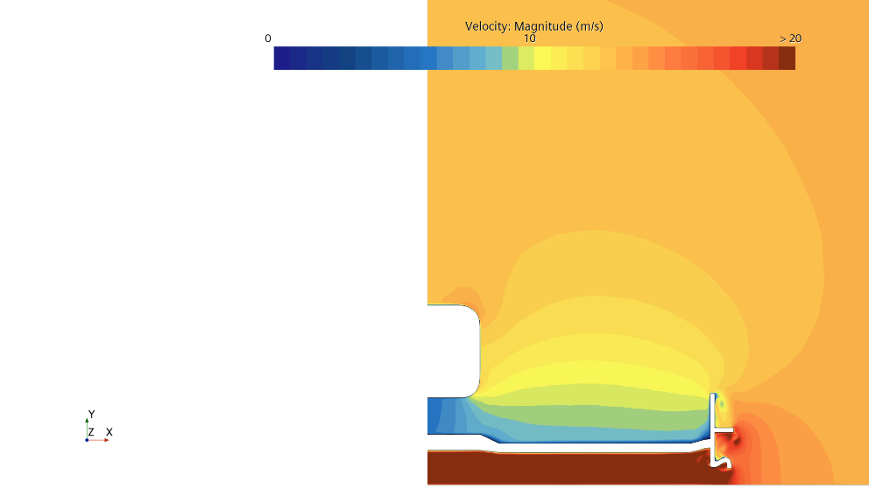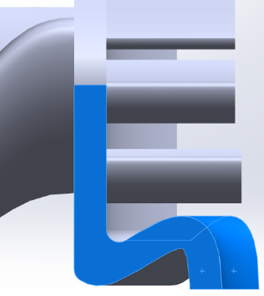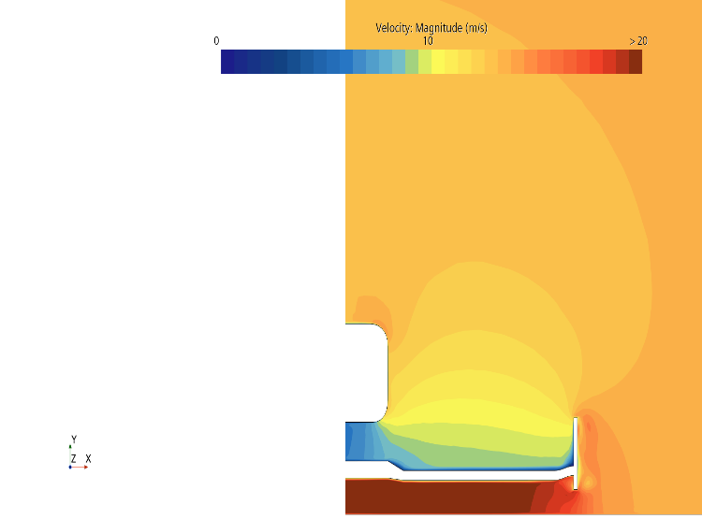
Figure 26: Front view streamwise velocity plots of front wing main element without and with footplate.
A key design feature of the front wing is the footplates. These ingenious semicircular canals seal the flow by generating small-scale footplate vortices to restrain the surrounding airflow from bleeding into the low-pressure region. Figure 26 illustrates how the front wing operates properly with footplate installed below the endplates.
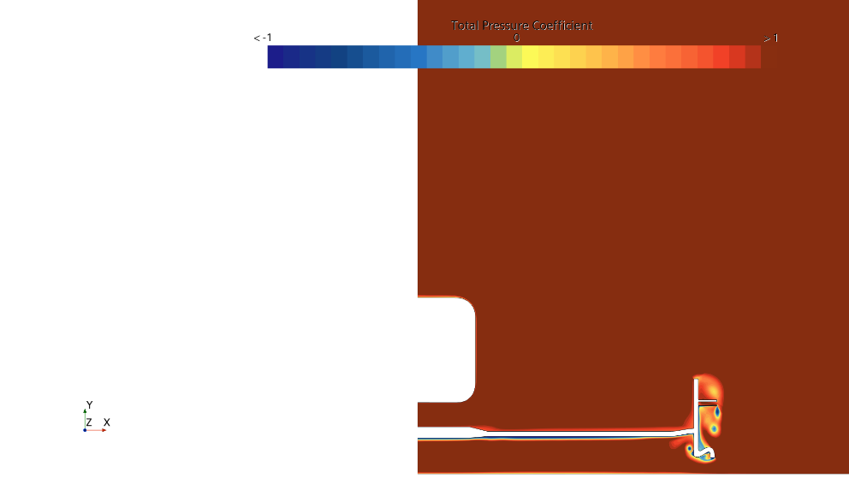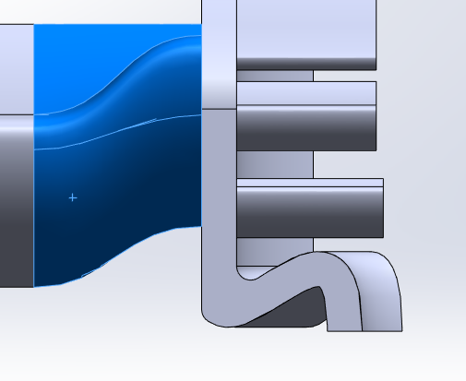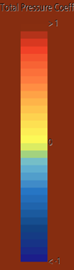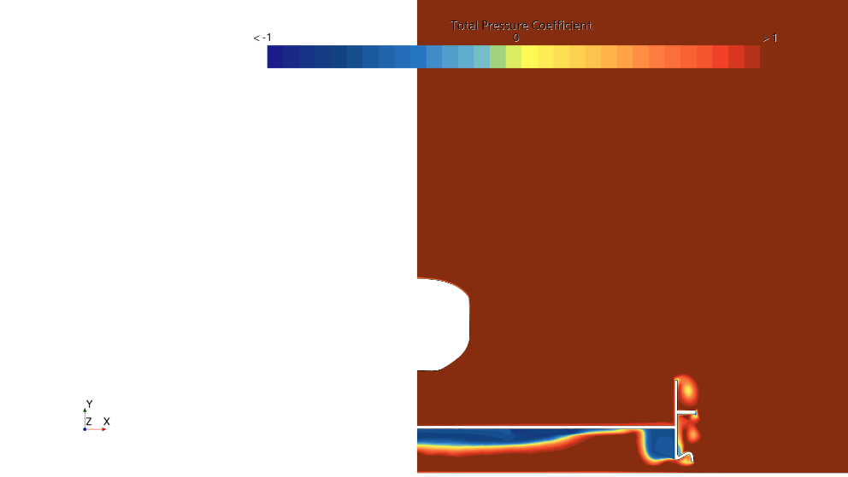
Figure 27: Front view CpT plots of front wing main element without and with lofting.
However, there is a burst of vortex emanating from the footplate causing appreciable deterioration to the downforce, which is an undesirable phenomenon. The issue is tractable by the introduction of a short lofting section at the tip of the wing, like a wing with a washout. It is evident in Figure 27 that the space created by lofting consumed the vortex which alleviates the situation. Also, it is worth mentioning that the midspan is modified to have a symmetry profile (NACA0012) so that the flow would not impinge on the nose cone. Another novel design is that the current front wing has detachable secondary wing elements in which one can vary the angle of attack, which allows more permutation to be conducted during the wind tunnel experiment.
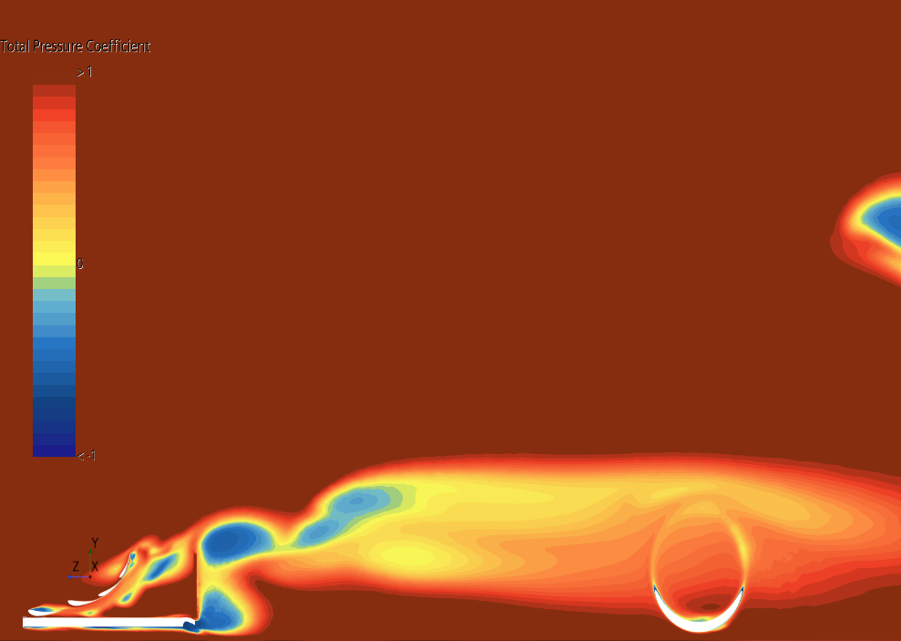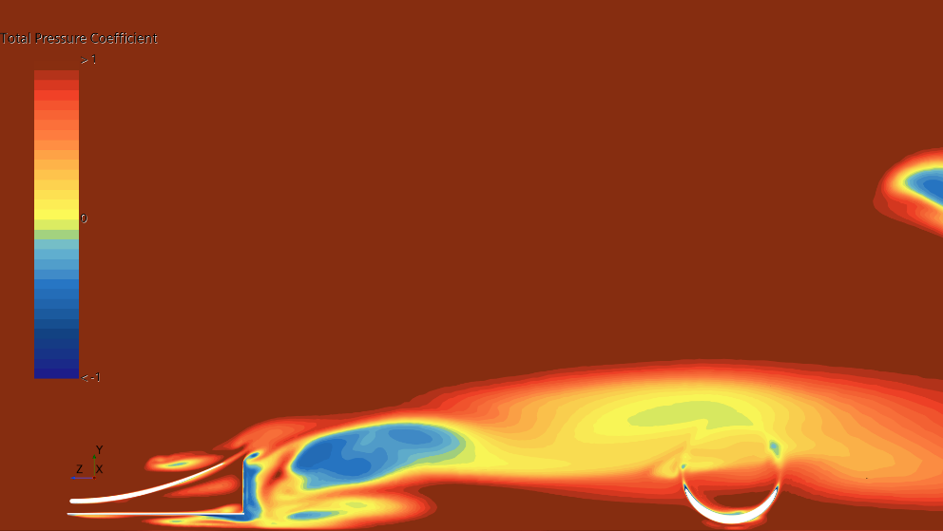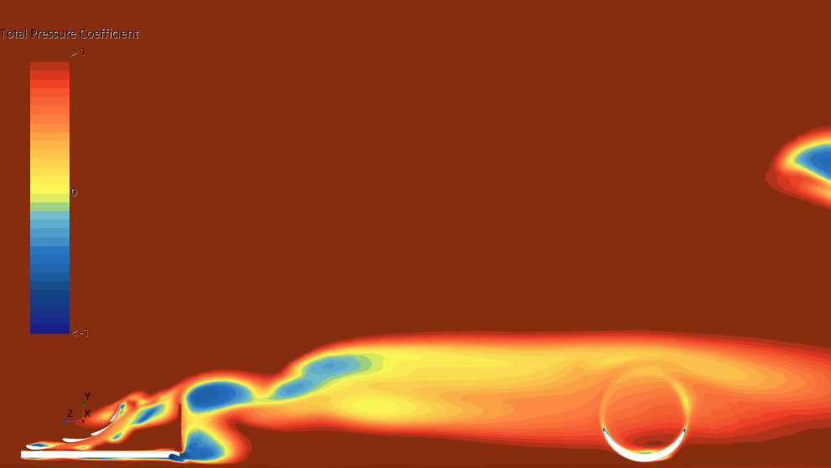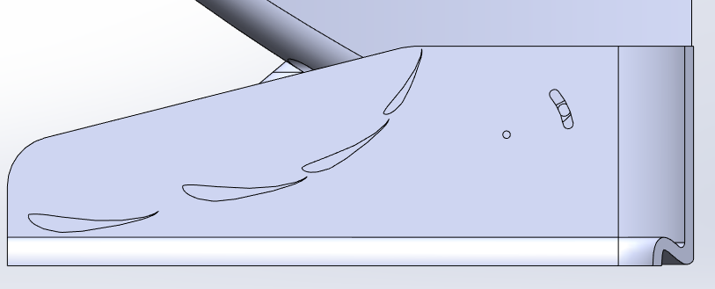
Figure 28: Side view CpT plots of canard element (Phase 5) and current winglets configuration.
Another aspect that has been improved is the flow deflection mechanism on the outer plane of the endplates. Rather than a canard/slot, the winglets are equally good at turning the flow up and around the front wheels but with less aerodynamic loss, as displayed in Figure 28. In addition, the endplate curve elegantly wraps the flow around the front wheels to reduce wheel drag and wake region. It is later verified by utilising the smoke wand flow visualisation method as part of the wind tunnel testing.

Finite Element Analysis
FEA was conducted on the initial front wing design using ANSYS Mechanical to test the structural integrity of the design. A tetrahedral mesh of 0.005mm was generated on the part. The ends of the pylons were set as fixed points as they were going to be attached to the spine. A force of 30.62N acting downwards was added to the top surface of both the main and secondary wing element simulating the aerodynamic forces which will be experienced by the front wing during wind tunnel testing.
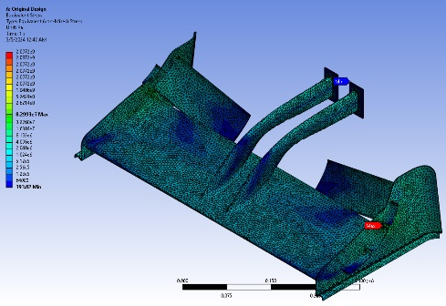
Figure 29: von Mises yield criterion plot for the initial front wing design.
The result of the FEA analyses can be seen in Figure 29 and 30 that there is going to be an excessive deflection occurring on the unsupported end of the secondary element. To mitigate the issue, inner endplates were incorporated to enhance structural integrity, preventing the secondary element from bending excessively when subjected to aerodynamic loads. It essentially transforms a cantilever wing into a fixed-ended wing. The nosecone was also added to the front wing to be manufactured as an entire piece to reduce the stress experienced by the pylons under aerodynamic load. FEA analysis was then conducted on the improved front wing to ensure that the problems that existed in the initial design were rectified.
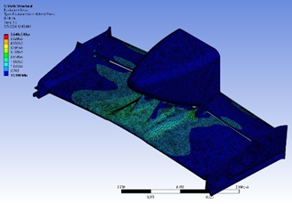
Figure 30: von Mises yield criterion plot for the improved front wing design.

DESIGN ITERATIONS
The front wing design has undergone numerous iterations aimed at optimising aerodynamic performance. CFD simulation has played a vital role in this process, allowing one to analyse and refine designs before physical testing. Early design iterations of the front wing prioritised simple designs, while later iterations incorporated more advanced features such as lofting. Table 2 presents the number of design iterations and corresponding CFD results. Across the design phases, lift (or downforce) has increased while drag force has decreased compared to the last year’s front wing design. Although the achieved downforce might not match that of previous model as expected, the design allows for variable angles of attack for the secondary wing element, indicating progress in aerodynamic flexibility and potential performance gains.

Table 2: CFD data for various front wing iterations.
 | Lift [N] | Drag [N] | L/D | FW SCL | FW SCD
Iteration 1 | -168.68 | 81.714 | 2.06 | -0.486 | 0.071
Iteration 2 | -164.70 | 84.787 | 1.94 | -0.578 | 0.096
Iteration 3 | -179.73 | 86.064 | 2.09 | -0.669 | 0.118
Iteration 4 | -191.73 | 91.256 | 2.10 | -0.670 | 0.191
Iteration 5 | -208.49 | 89.070 | 2.34 | -0.820 | 0.137
Iteration 6 | -221.771 | 86.438 | 2.57 | -0.998 | 0.131

Final Design
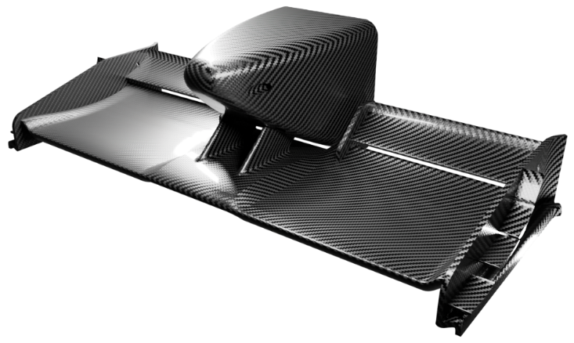
Figure 31: Rendered isometric view of the front wing final optimised design.
Eventually, months of iterations proved fruitful following the advent of a full-fledged prototype, see Figure 31. It boasts a feasible design where the pylons directly join the main wing element and nose cone together to ease fabrication and assemblage whilst preserving modularity. Its lift-generating ability outperforms the 2023 model at 45° incidence and generally maintains lower drag values, as in Figure 32.
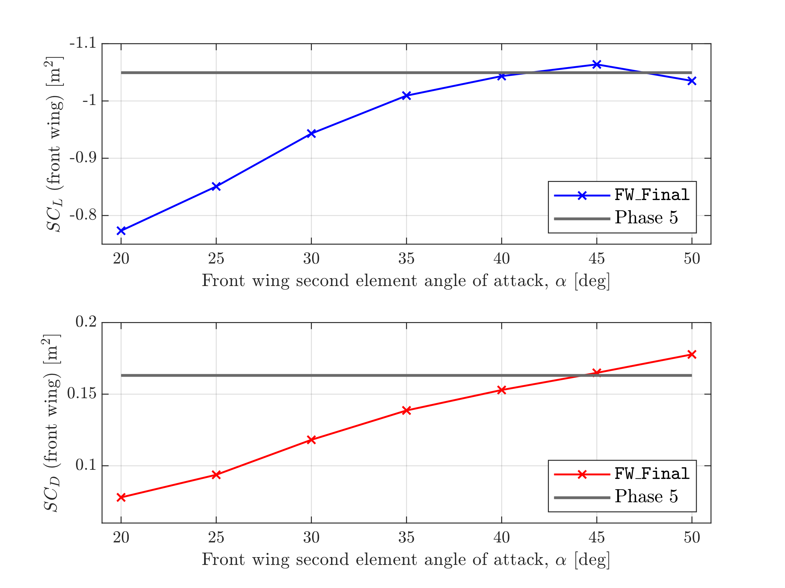
Figure 32: SCL and SCD plots of the front wing final iteration compared to Phase 5 (2023 model).
Table 3: CFD data for different angles of attack of front wing second element.
FW second element incidence [deg] | Lift [N] | Drag [N] | L/D
20 | -199.592 | 84.288 | 2.368
25 | -203.400 | 83.269 | 2.443
30 | -211.993 | 85.434 | 2.481
35 | -222.713 | 86.798 | 2.566
40 | -226.853 | 88.957 | 2.550
45 | -229.116 | 90.245 | 2.539
50 | -221.602 | 90.897 | 2.438

The provided data in Table 3 presents the results of CFD analysis for varying angles of attack of the second element of the front wing. Firstly, there is a general increase in lift force, reaching its peak magnitude at 45 degrees of incidence. However, beyond 45 degrees, the lift force starts to decrease slightly, due to flow separation. The drag also increases as the angle of attack rises. This is expected due to the increased interaction of the airflow with the wing surface at higher angles, resulting in higher drag forces. This results in a trade-off between lift and drag, reflected in the lift-to-drag (L/D) ratio, which peaks at around 35 degrees before gradually decreasing at higher angles of attack. These trends highlight the importance of carefully selecting the angle of attack to optimise the balance between lift generation and drag reduction for efficient aerodynamic performance.

Table 4: Comparison of CFD and wind tunnel data.
Model | Lift [N] | Drag [N] | L/D
2023 (CFD) | -246.773 | 92.426 | 2.670
2024 Wind tunnel (35°, h=45mm) | -228.130 | 93.892 | 2.430
2024 CFD (FW-35AoA) | -222.713 | 86.798 | 2.566

From Table 4, it is evident that there are differences between the two models in terms of lift and drag. The 2024 model exhibits slightly lower lift and drag compared to the 2023 model. However, the lift-to-drag (L/D) ratio remains relatively consistent between the two models, with the 2023 model having a slightly higher L/D ratio than the 2024 model. These differences indicate potential variations in aerodynamic performance between the two models, with the 2024 model possibly demonstrating improved efficiency in lift generation or drag reduction compared to the 2023 model. Additionally, it's noteworthy that the 2024 front wing exceeded SCL at 45 degrees compared to the 2023 model, suggesting advancements in aerodynamic design or performance enhancements in the 2024 model.

The WT data show a slight difference in both lift and drag coefficients compared to the CFD data, with increases of 2.37% and 7.55%, respectively. However, L/D exhibits a 5.58% increase in the CFD results compared to the wind tunnel measurements. These variations highlight the nuanced differences between experimental and computational methods, reflecting discrepancies in capturing the aerodynamic characteristics of the system.

Sidepods

Ground Effect Concept
As mentioned previously in this report, ground effect was going to be used as much as possible to improve performance. To do this, the initial side pod design was inspired by F1 sidepods as they utilise ground effect most effectively of any worldwide racing series.

Initial Iteration
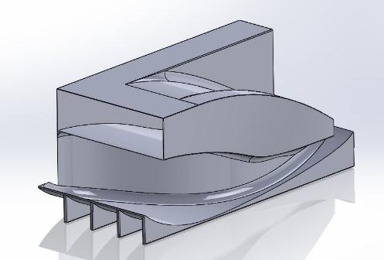
Figure 33: Initial sidepod design.
This first iteration was very simplistic, and it did not perform well in CFD. There were 2 main goals to be used in this design: firstly, the underbody was curved as this would create a venturi tunnel which would constrict the flow, creating a region of low pressure under the car, creating downforce. The strakes were added underneath to try and straighten the flow during cornering to encourage it to travel through the smaller cross section.
The other idea was to feed high energy air downstream of this component. This would help with rear tyre squirt and keep the turbulent wake of the tyre away from the diffuser, reducing its efficiency. This goal was aimed to be achieved through many geometry decisions. Firstly, the undercut between the inlet and the floor that travelled along the length of the sidepod would encourage flow to follow along using the Coanda effect and would be fed towards the diffuser. It would also have a secondary effect of pushing some air outwards, increasing outwash. Another similar concept is the sloped “slide”-like design on the top surface. What this does is takes the near freestream flow from on top of the chassis and feeds it towards the diffuser. The final thing is that by constricting the exhaust of the sidepod, the air would be forced to accelerate out of the sidepod towards the rear of the car.

Iteration 2
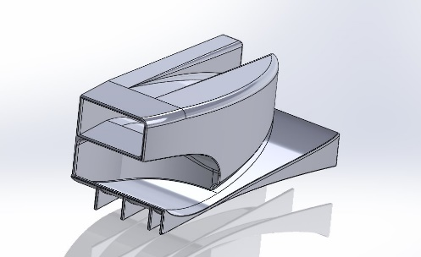
Figure 34: Second sidepod design.
This was a much more refined version of the previous design. It aimed to gain performance by trending further towards the design of Formula 1 sidepods. A top down C_{P}T plot of a slice of the sidepod can be seen in figure 38.
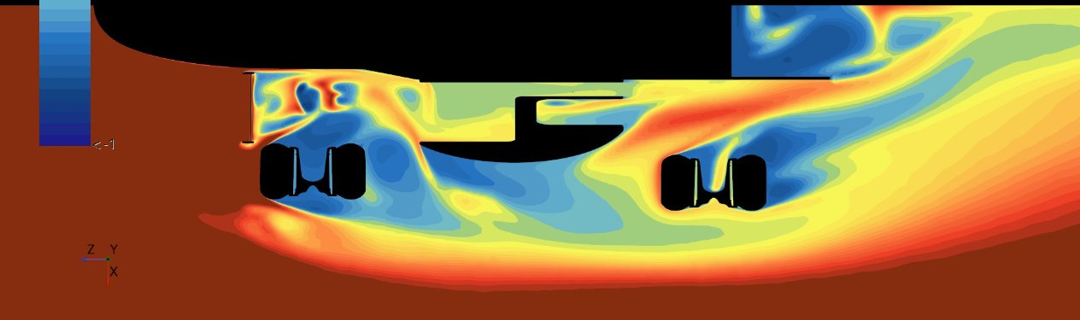
Figure 35: Top down CpT plot of the 2nd sidepod design.
The undercut is having an effect in pushing air outwards. The idea of guiding high energy flow between the tyre and the chassis is also clearly working as the low-pressure region is being kept away from the diffuser but it could be better. Below in figure is a side slice of total pressure.
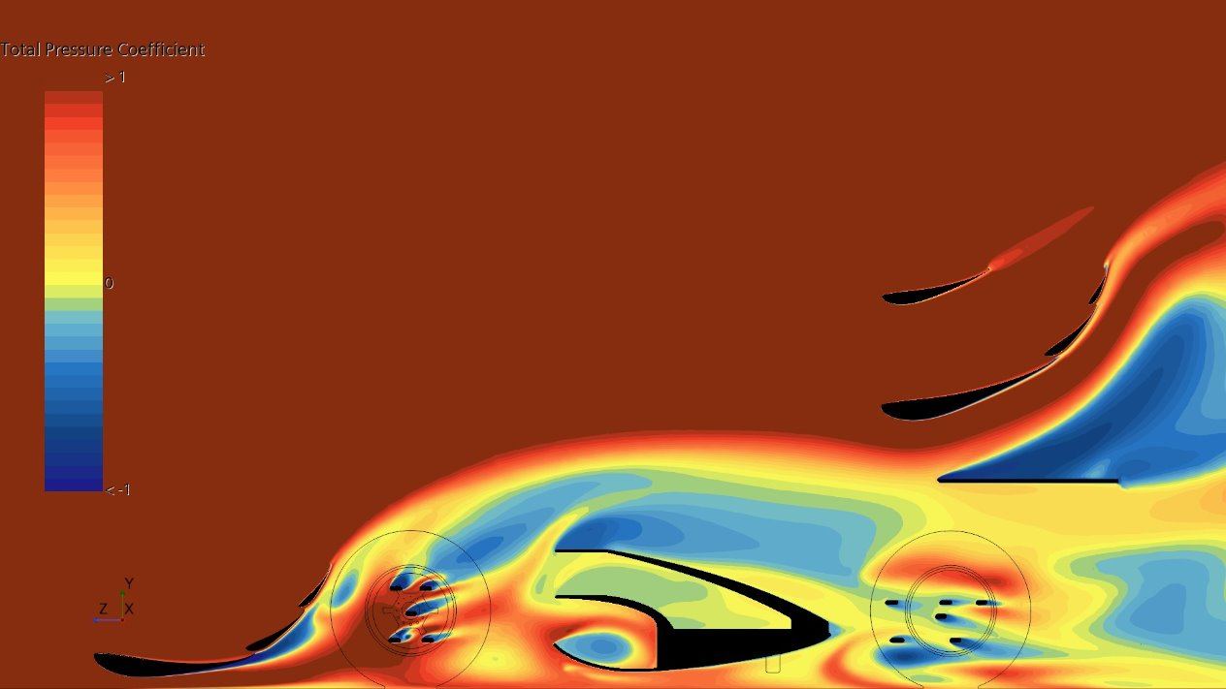
Figure 36: Side on CpT plot of the 2nd sidepod design.
This shows that there is a lot of separation on the top of the sidepod this is bad because it means there is more drag as well as the flow heading to the rear of the car down the “slide” being lower pressure which is not good for diffuser performance.

Final Iteration
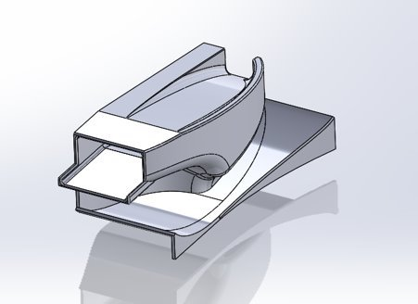
Figure 37: Third sidepod design.
The changes to this design included adding the extension in front of the inlet to try and reduce separation on the top. The strakes on the bottom were removed to explore a lateral expansion idea. Finally, the “slide” was widened. This was done so that the outer wall would be thinner and could possibly introduce a spilling effect over the top to generate more downforce.
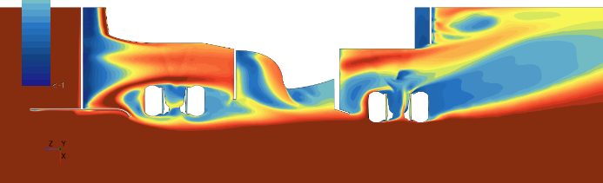
Figure 38: Top down CpT plot of sidepod 3.
This plot shows that the changes had been successful in managing the rear tire squirt as the tyre wake is separated much more from the diffuser external flow.
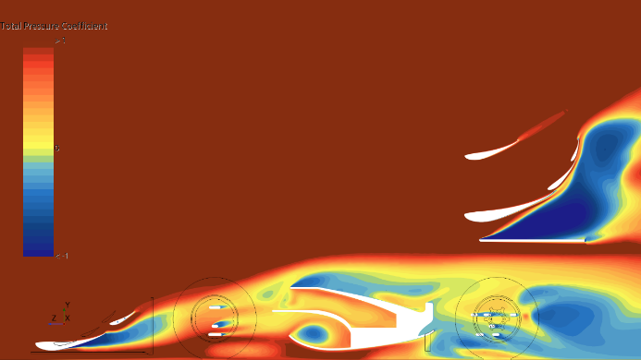
Figure 39: Side on CpT plot of sidepod 3.
This shows how the changes has reduced the amount of separation. Both the top surface and above floor separation has been improved.
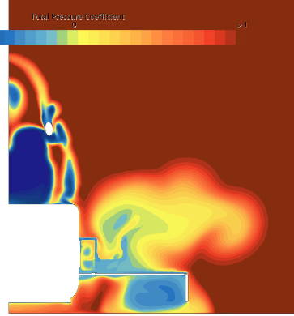
Figure 40: Front on CpT plot of sidepod 3.
Finally, this shows that the removal of the strakes has allowed for a large low-pressure region to form under the car which is good and optimal for performance gains.

Comparison to Previous Year
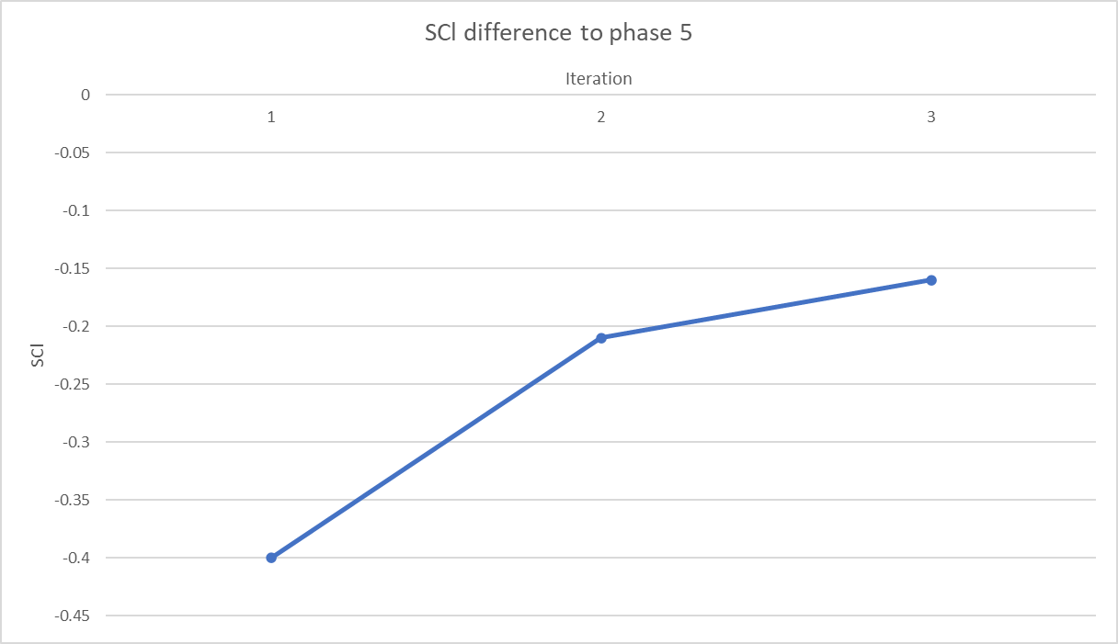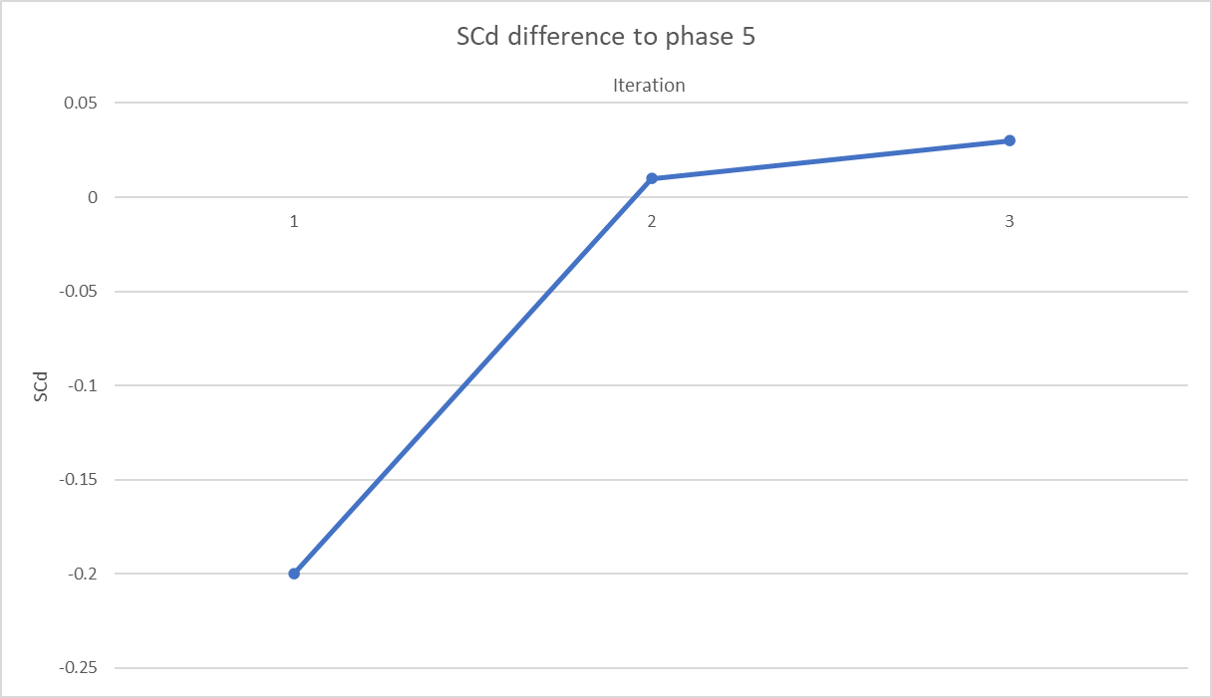
Figure 41: Comparison of the performance between this year’s design and the previous year’s (phase 5) design.
These performance results are promising however, the difference in downforce is still larger than would be liked. However, there aren’t many obvious areas where this could be resolved with the current concept and so a new avenue needs to be explored.

Wheel Guard Design
Instead of taking inspiration from Formula One aerodynamics, where designs are heavily restricted, the next concept would be inspired by IndyCar and other Formula Student cars. These are being considered because IndyCar is a very low drag concept due to the fact they run on ovals and Formula Student is the discipline this car is designed for (however with 11/19 DNFs last year [7], they still may not be the best inspiration).

Low Drag Design
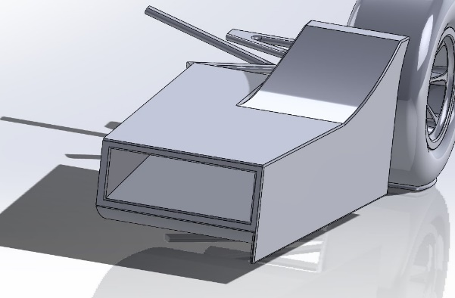
Figure 42: Simple new sidepod design.
This design is very simplistic. It does not have any overbody aerodynamics and the main source of downforce production will be the underbody venturi tunnel. The wheel guard will also produce some small upwash which will help slightly and by reducing the airflow to the rear wheel, it will reduce the lift the tyre generates.
This design already performed better than the previous ground effect design, producing a SC_{D} 0.05 lower meaning it is also less draggy than last year’s. Unfortunately, due to the simplicity of this design there also isn’t much room to change things.

Aerofoil SIdepod Design
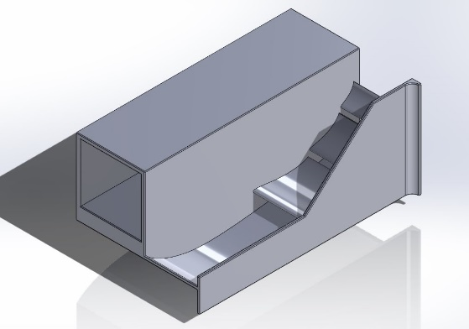
Figure 43: 5th sidepod design.
This design is inspired by a lot of other high end formula student cars. It keeps the existing ground effect design but now it has aerofoils outboard of the sidepod inlet to create more downforce while still guarding the rear wheel by producing upwash.
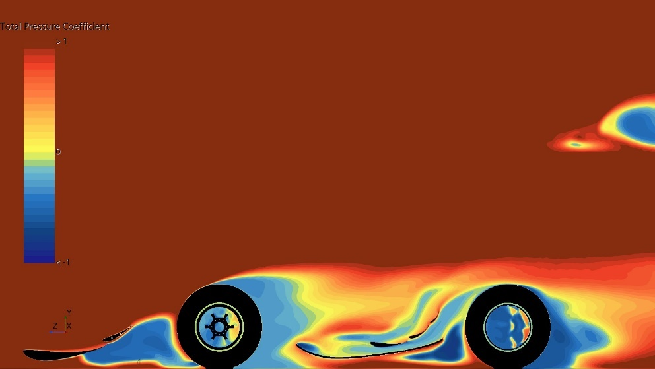
Figure 44: Side on CpT slice of 5th sidepod design.
This CFD slice shows that the design is working almost as hoped. The only point of concern is the point of separation at the leading edge of the floor. There is a lot of low pressure produced beneath the mid car and the aerofoils are producing good amounts of lift with no separation and also directing flow away from the rear wheels.

Aerofoil Developed Design
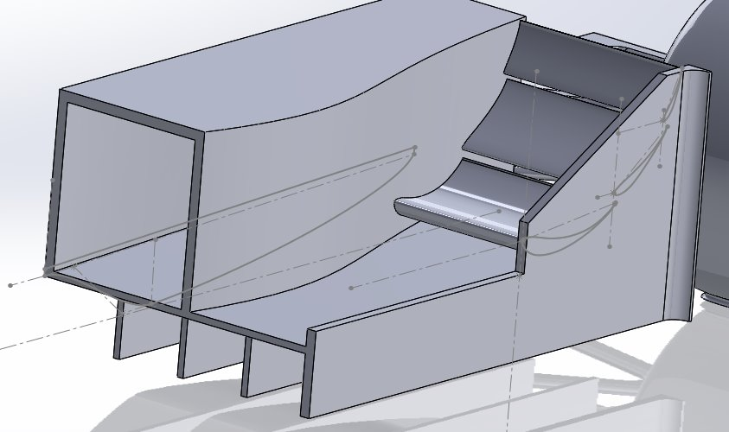
Figure 45: Final sidepod design.
This design attempted a few things: it added strakes underneath as the flow was moving laterally a lot, The leading floor edge was flattened a bit to try to decrease separation, the exhaust of the sidepod is reduced in area to accelerate the flow towards the diffuser as well as allowing for a wider span of the aerofoils. Unfortunately, this did not produce the results expected and increased drag and reduced downforce.

Modeling of Radiators
The final part of the design process was modelling the radiators inside of the sidepod. To do this, a second region was made in CFD and it was made as a porous region. The radiator was modelled as a simple cuboid with the dimensions of the radiator mentioned in the cooling section. Ideally, the parameters for the radiator porosity would have been gathered experimentally, however there was not enough time or resources for this so the values used were the commonly accepted values for car and motorbike radiators.[13]

Suspension
The suspension design was a critical focus when deciding areas for model development of the preceding project. This emphasis stemmed from the limited travel distance of the existing suspension system, which limited the range of ride heights that could be tested in the wind tunnel. Additionally, structural failures occurred in the suspension which were discovered during the disassembly of the model, finding that a temporary fix using aluminium tape was being used to complete the tests. These failures were likely due to the rigidity of the suspension coupled with the constant vibrations from the rolling road, which constrained the group to reduced road speeds of 4-10m/s in their tests.
For the new design, we were looking to improve the robustness of the suspension system to prevent any similar failures reoccurring. We also wanted to endure that modularity was a key goal, with the new suspension system being designed to attach to the car in a way individual parts could easily be replaced or upgraded or the whole system could be developed further and easily replaced. Given the importance of the suspension in determining the allowed movement of the chassis in relation to the ground when testing the model with its wheels on in the wind tunnel, it was imperative to design a suspension that would allow for sufficient travel for a large ride height range.

Push Rod Concept
We decided to develop a pushrod suspension concept, like the current SUFST car. A simplified version excluding springs and dampers was decided upon to mitigate the effects of undesirable force balance influences. The design was developed to incorporate adjustable push rod lengths to allow easy control over the minimum ride height of the car. The inclusion of the push rod also allowed for absorption of vibrations in the system without any damage. Coupling the push rod with a rocker mechanism, this design allowed for ride heights between 10-50mm to be tested, which exceeded the minimum requirements we set out at the beginning of the design process.

Rocker Design
The evolution of the rocker design within the suspension system went through several iterations to optimise its functionality, maximising the range that the suspension can travel. Figure 46 illustrates this progression, with the first iteration on the left and the final iteration on the right.
The primary objective was to accommodate sufficient suspension travel across various ride heights, achieved by the rocker rotating when acted upon by the pushrod. However, the geometry of the initial design limited this travel to only 5mm. To address this restriction, the spacing between the mounting locations of the pushrod and the rocker to the rocker mount were increased.
Successive iterations, particularly the design pictured in the middle of Figure 46, demonstrated progress by providing a suspension travel of 30mm, this was due to the removal of a second mounting point. Although this design improved functionality of the suspension system, it limited future developments being made within the suspension system.
The final iteration of the rocker design allowed for the largest range of travel tested so far, with a measured travel range of 40mm. Additionally, this design is of a more traditional rocker configuration addressing the complaints with the previously mentioned iteration. This design featured an additional mounting point opposite to the pushrod, facilitating future integration of a damper into the suspension system or the inclusion of actuators to control the ride height of the car.
The improved design not only enhances the functionality of the suspension system, but also ensures ease of future developments and could also facilitate scalability for future projects, including the potential of being used in a full-scale model
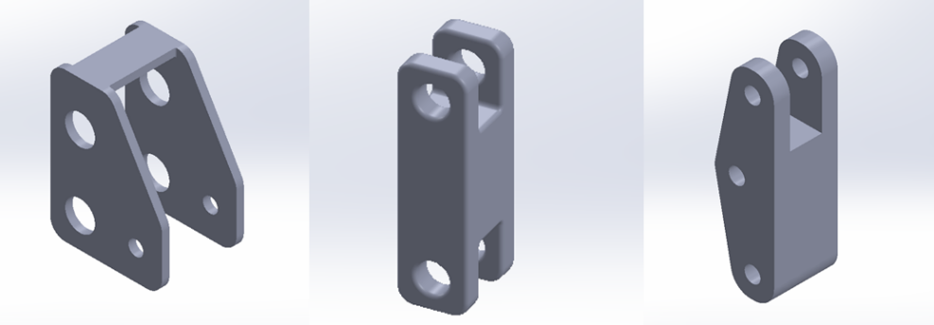
Figure 46: Iterations of Rocker Design.

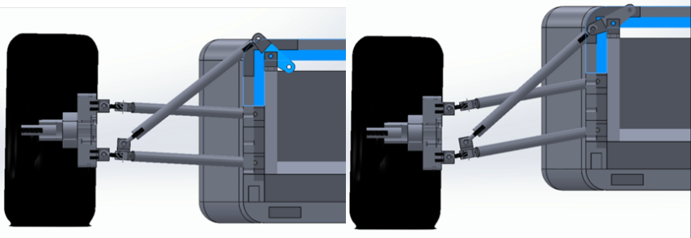
Figure 47: Pushrod suspension system with rocker allowing change of ride height.

Steering Arms
Introducing steering arms introduced the option of completing a wider range of programs in the wind tunnel beyond just straight wheel scenarios. The steering arm configurations designed would allow for the steering angle of the front wheels to be controlled between -20º to 20º in fixed increments as shown in figure 49, with individual control arms being manufactured to facilitate each angle as shown in figure 48. This would enable yaw testing to be completed, providing us with an insight into the aerodynamic performance under cornering conditions, and would allow for further optimisation of aerodynamic components such as the front wing to ensure consistent performance over a range of driving conditions.
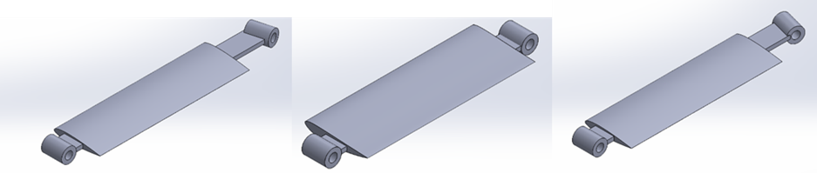
Figure 48: Steering arms for suspension system: Left: 20º, Middle: 0º, Right: 20^{O}.
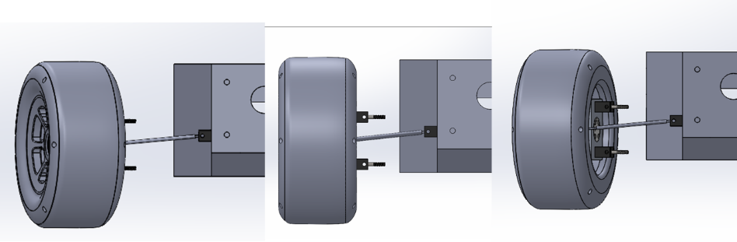
Figure 49: Assembly of steering arm to the wheel.

Final Design
The final suspension system comprised five primary components: the upright, the two wishbones, the push rod, and the rocker. Each individual component was manufactured for the wind tunnel model, with key improvements being made over the previous year’s model.
Each wishbone was mounted to the spine in CAD to allow for accurate mounting positions to be determined and to act as reference when modifications were made to the supplied spine. This also allowed for a maximum boundary to be considered when designing the bodywork and any additional aerodynamic components. The wheels were bolted directly to the hubs, with the bearings inside the wheels allowing for free rotation.
The purchased rod ends were beneficial as they provided very low friction whilst they allowed rotation, this ensured that there wouldn’t be any load transferred between the rolling road and the cars spine which would have had an influence on the forces read by the wind tunnel balance, this was supported by the design of the rockers being allowed free rotation within their mounts, mitigating the influence of vertical forces acting on the spine and affecting the recorded downforce.
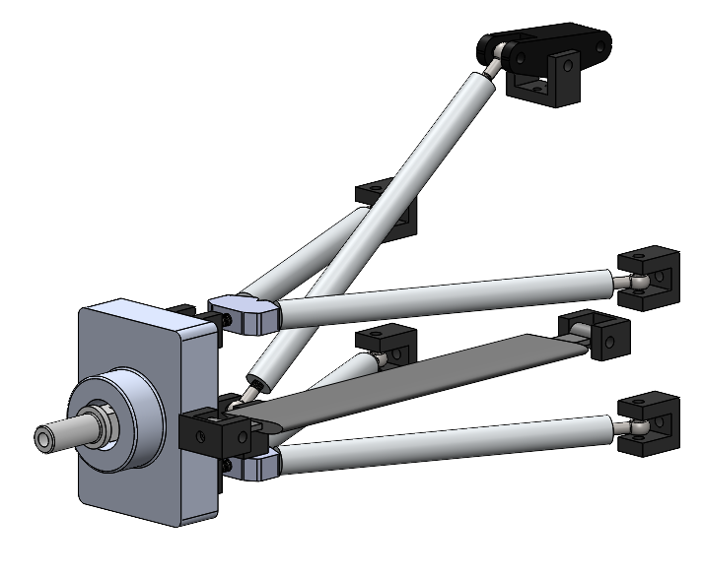
Figure 50: Final Iteration of Suspension system assembly.

Finite Element Analysis
FEA studies were utilised throughout the design process of the suspension using ANSYS Mechanical to provide stress distribution modelling, deformation analysis and allowing us to predict the potential failure points of the design. A tetrahedral mesh of 0.025m was generated on the suspension assembly. With the mounting points to the spine acting as fixed points. A force of -4.5N was acting horizontally on the wheel simulating the drag which will be experienced by the suspension assembly during wind tunnel testing. The inclusion of the forces from the downforce generated by the car was not included as during wind tunnel testing the model would be supported by the overhead sting, removing the effect of the aerodynamic forces on the suspension. The results of the manufactured suspension design can be seen in figures 51 and 53. As can be seen there is no deformation occurring when under wind tunnel simulated conditions. When analysing the stress distribution of the suspension system under simulated wind tunnel conditions, it is clear that the stresses incurred are within acceptable thresholds. This indicates that the designed suspension system will operate effectively without experiencing excessively high stress. As a result of these final FEA studies, no further design modifications were necessary and the designs were finalised and sent to the EDMC to be manufactured
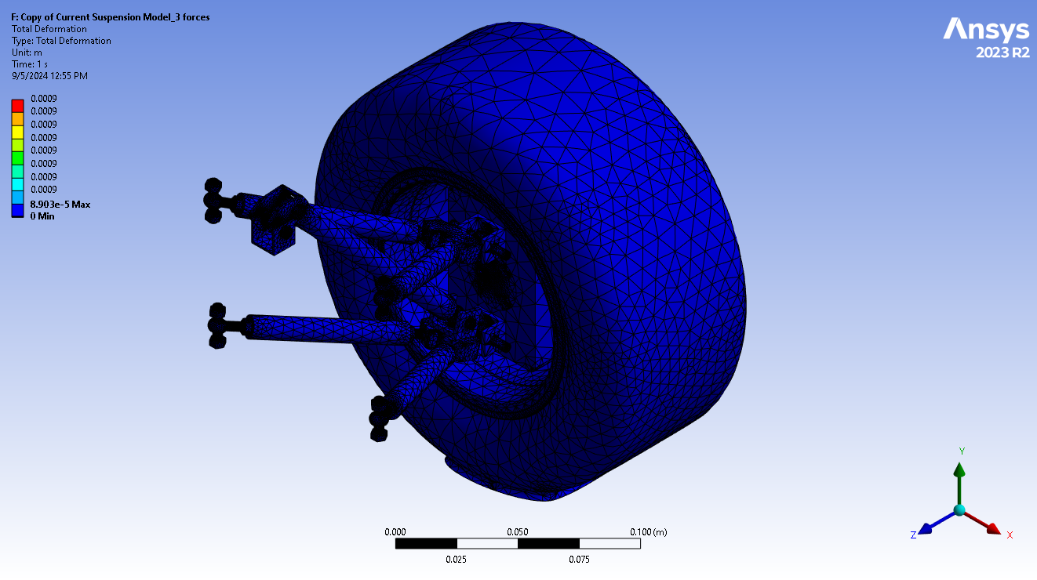
Figure 51: Deformation of the suspension system under simulated wind tunnel testing conditions.
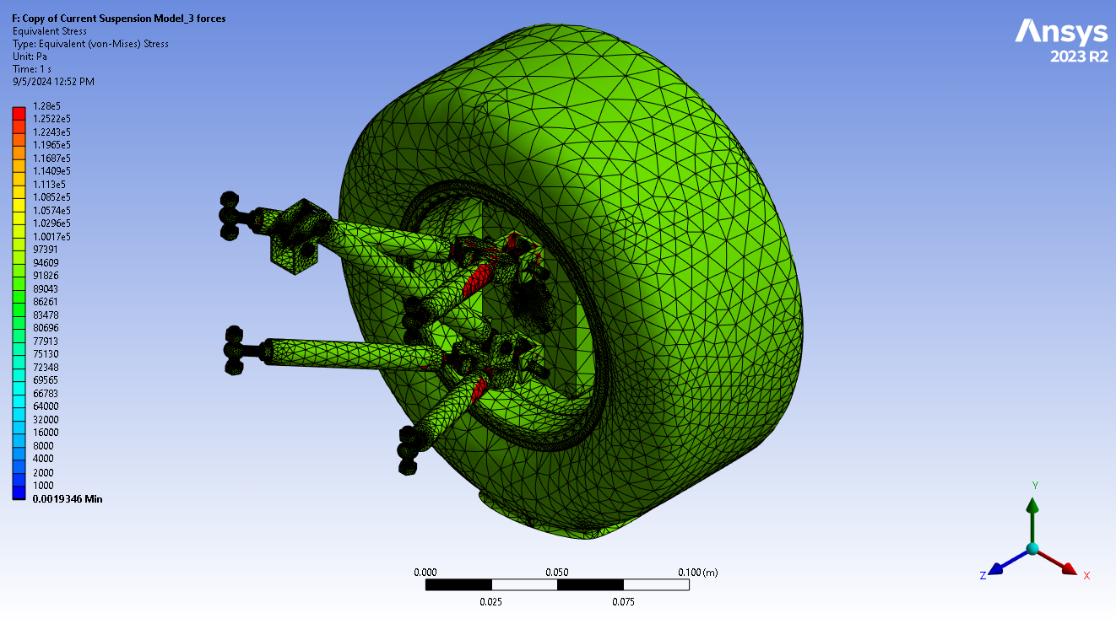
Figure 53: Stresses experienced by suspension system under simulated wind tunnel testing conditions (with wheels).

Bodywork
The bodywork of the wind tunnel model was also redesigned this year with the aim of reducing drag and creating a chassis that will easily allow the aerodynamic parts and suspension to be mounted and unmounted. The new bodywork which was designed will also be made from fewer pieces, reducing the number of parts that would have to be printed and assembled unlike the model from the previous year. However, inspiration was taken from last year’s design where the many individual pieces were friction fitted together but because of the tolerance and resolution of the print, many of the friction fitted parts were loose and a lot of tape was used to keep the pieces in place as seen in Figure… below. This not only reduces the visual appeal of the model; it will also affect the performance of the model during wind tunnel testing.
Taking inspiration from last year’s design and improving on their shortcomings, the new bodywork was designed to be like a shell which takes the shape and fully encapsulates the metal spine. The new bodywork would be made up of fewer pieces which will be friction fitted with each other. To further strengthen the assembly of the bodywork pieces, the pieces would be directly bolted to the metal spine. Therefore, holes would have to be made and aligned with the existing holes on the metal spine. However, the CAD files containing the metal spine from the previous group did not mark out the locations where the holes were made in the spine. This meant that physical measurements of the location of the holes on the metal spine had to be taken which complicated the process of aligning the holes on the new bodywork to the metal spine as the measurements was not going to be precise.
The initial design of the bodywork excluding the nosecone consisted of 9 different pieces with a wall thickness of 3 cm on each piece. However, the wall thickness of all the bodywork pieces were then reduced to 2 cm over concerns that the bodywork would be too thick and too heavy. Although having a smaller wall thickness will impact the structural integrity of the model, aerodynamic gains can be achieved with the smaller bodywork dimension as the length of the front wing can be increased while keeping within the dimension boundaries stated in the FSUK 2024 regulations. An increase in length of the front wing will increase the surface area of the wing which allows more downforce to be generated. The frontmost piece of the bodywork was designed to have extruded blocks and indents to allow the nosecone to be friction fitted to the rest of the bodywork. Small sections from some of the bodywork pieces were also cut out to allow the control arms from the suspension system to be fastened directly to the to the metal spine.
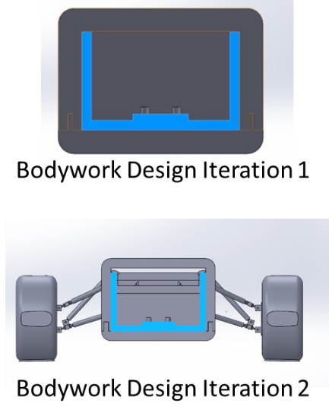
Upon assembling the rest of the aerodynamic parts and suspension system onto the bodywork, further minor modifications were made to the bodywork parts. The thickness of the top surface of the all the bodywork pieces was reduced by 1cm leaving some clearance for the movement of the rocker which will be attached to the metal spine as seen in figure 54. Further modifications were also made to the mid-section of the bodywork to accommodate sidepods. The changes made to the mid-section of the bodywork can be seen in figure 55 below.
Figure 54: Changes made to the wall thickness of the bodywork.
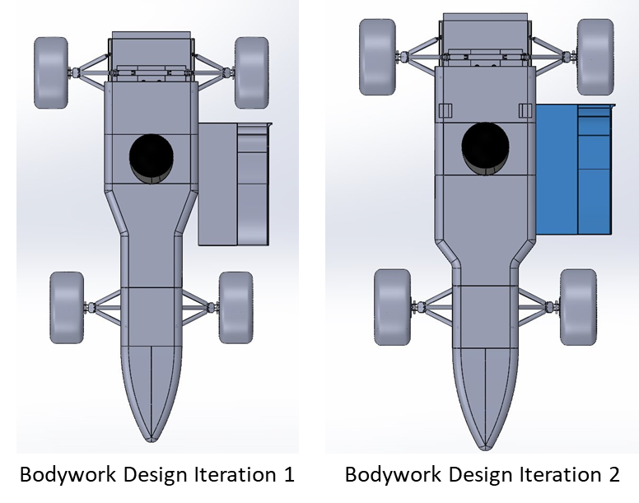
Figure 55: Changes made to the mid-section of car to accommodate sidepods.
An exploded view along with a completed assembly of the final design of the bodywork with the nosecone attached can be seen in figure 56.
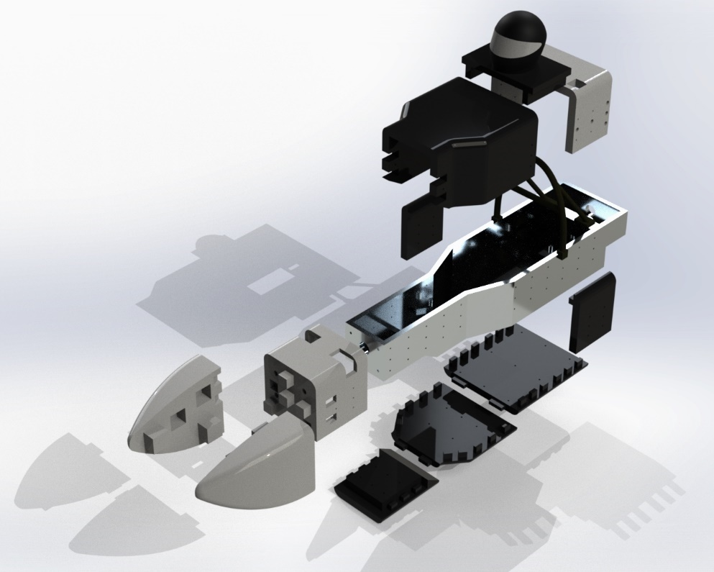
Figure 56: Exploded view of the bodywork assembly
Initial data gathered through CFD simulations showed a decrease in drag coefficient of 0.051 from 0.344 in the previous year’s bodywork to 0.2929 from the newly designed bodywork for this year’s model. This represented a 14.83% decrease in the total drag coefficient between the two models from this year and the year before.

Whole Car final design
Every component of the car underwent optimization processes, as explained in the report. From the aerodynamic elements to the mechanical systems, each component was studied and refined to achieve peak performance. The different components and systems were then integrated to create a cohesive and optimized unit. Throughout the design process, different combinations of the front wing, sidepods and bodywork were analysed in CFD. Figure 57 shows the final whole car assembly.
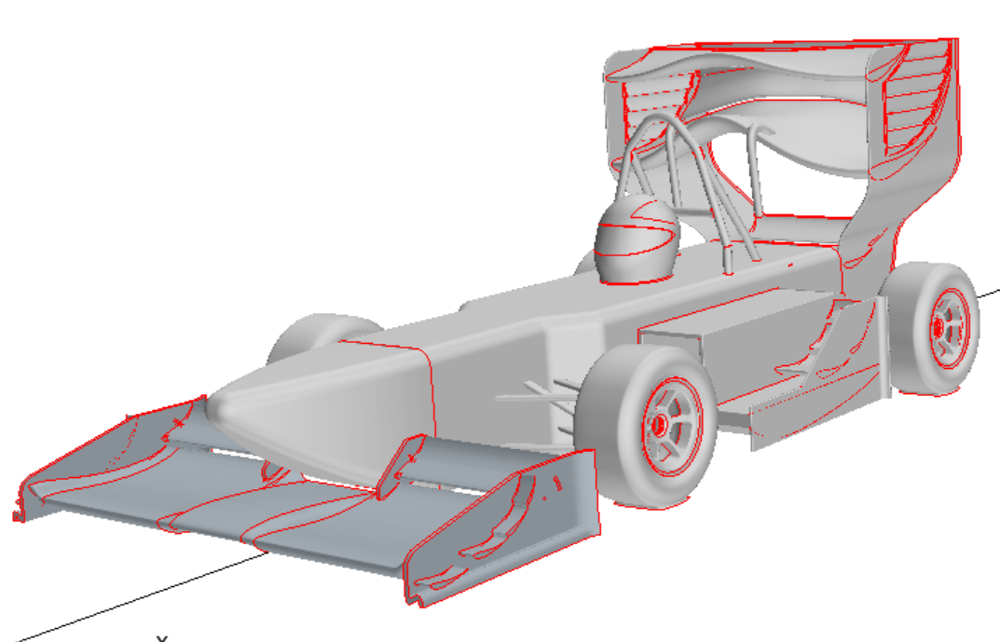
Figure 57: Whole car geometry on Star-CCM.
Table 5: Whole car CFD results.
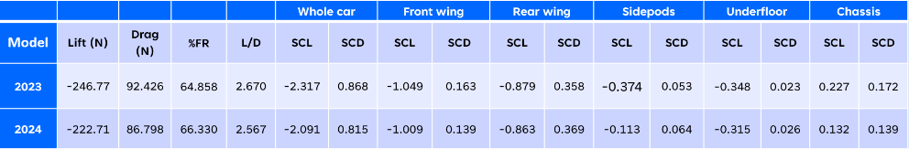
During the thorough evaluation of the car's overall aerodynamic performance, notable variances became apparent when comparing the 2024 model with its predecessor. Downforce experienced a decrease of 9.75% compared to the 2023 model. Concurrently, drag exhibited a 6.09% reduction, signifying improvements in enhancing the efficiency. Focusing on the front wing analysis, the FW achieved its highest downforce output at a 45-degree angle, potentially indicating an optimized design catering to higher angles of attack. Moreover, the FW demonstrated its most favourable lift-to-drag ratio at 35 degrees, highlighting an optimal balance between lift generation and drag reduction.
Despite experiencing a reduction in lift generation compared to 2023 model, our decision to incorporate sidepods into the design has yielded a significant enhancement in cooling capacity. By strategically integrating these sidepods, we have effectively optimized the vehicle's aerodynamic profile while simultaneously addressing crucial cooling concerns. As a result, the overall performance and reliability of the vehicle are expected to undergo a substantial improvement, demonstrating the effectiveness of our design approach.

Wind Tunnel Model Manufacturing
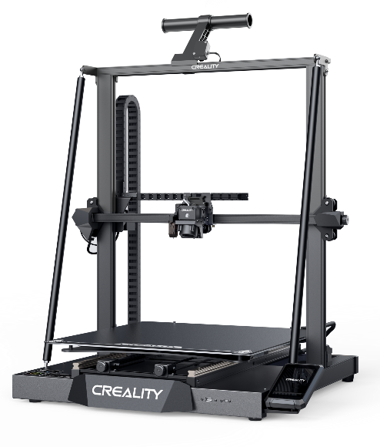
To reduce project cost this year, some parts from the previous year’s model were reused. The reused parts include the metal spine, rear wing, roll hoop and diffuser. 3D printing was chosen as the primary method of manufacturing all the bodywork and aerodynamic parts for this year’s wind tunnel model. Instead of outsourcing external 3D printing companies to print the parts as did in the previous year, a Creality CR-M4 3D printer with a build volume of 450mm*450mm*470mm was used to print all the parts. The 3D printer had a 0.4mm nozzle which allowed 3D printing filaments of 1.75mm in diameter to be used. The 3D printing software that was used to slice the parts to be saved as .gcode for 3D printing was Creality Print.
Figure 58: Creality CR-M4 3D printer.
PETG was the preferred filament material compared to PLA due to its higher strength and flexibility. The tensile strength of PETG is around 50MPa while the tensile strength of PLA is around 65 MPa [14]. This makes PETG less brittle and more impact resistant compared to PLA which are desired material properties when manufacturing aerodynamic parts that are subjected to various aerodynamic stresses during wind tunnel testing. However, the melting point and glass transition temperature of PETG is higher than PLA as seen in table 6 below [15]. This means that a higher nozzle and print bed temperature is required when printing PETG to avoid under-extrusion issues from occurring.
Table 6: Material Properties of PETG and PLA.
Material | Glass Transition Temperature (°C) | Melting Point (°C)
PLA | 55-60 | 150-180
PETG | 80-85 | 220-260
PETG also has excellent layer adhesion resulting in prints that have high structural integrity and fewer issues of delamination in between printed layers [14]. However, PETG is more sensitive to print speed compared to PLA. If the print speed is too high, the newly extruded material may not stick to the layer below [16]. This means that models printed using PETG will take longer than models printed using PLA. Although stronger and more flexible, PETG is slightly trickier to print and is heavily dependent on printer settings. Changes to printer settings such as increasing or decreasing nozzle and print bed temperature as well as cooling speeds will cause layer adhesion issues.
During the manufacturing of the bodywork pieces and aerodynamic parts different combinations of print temperatures and print speeds were tested to find the most optimised printer settings that can print a part with the least amount of time required. Different infill densities, infill patterns and support densities were also tried for different parts according to the stresses that the part will experience. The combination of printer settings that were found to have work best for the PETG filament that was purchased and used to manufacture all the bodywork pieces and aerodynamic parts are as seen in table 7 below.
Table 7: Printer settings used to 3D print the parts.
Parameters | Value
Nozzle Temperature | 240
Print Bed Temperature | 80
Fan Cooling | 100
Initial Layer Print Speed (mm/s) | 15
Infill Print Speed (mm/s) | 100
Infill Density (%) | 15
Infill Pattern | Cubic
Support Density (%) | 10%
Support Pattern | Zig Zag

Infill patterns are essential in the structural integrity of a 3D printed part. Different infill patterns have different properties which can greatly affect the strength of the 3D printed. For prints that are only for cosmetic purposes, infill patterns such as line and zig zag will provide sufficient strength and flexibility while taking lesser time and material to print. For functional prints that will need to withstand stresses, infill pattern such as cubic and octet are chosen because internal structure of the pattern creates a strong internal frame which enables the print to withstand relatively large stresses [17]. Cubic was chosen as the infill pattern of choice for printing all the bodywork and aerodynamic parts because of its 3D infill strength and because cubic infill patterns take a relatively shorter time to print compared to other strong 3D infill patterns.
The infill density also plays a role in determining the structural integrity of a 3D printed part. The higher the infill density of a part, the stronger the part but the trade-off is that it uses more material and that it takes a longer time for the part to print. The infill density also is dependent on the purpose of the part, cosmetic parts can be printed with around 10% of infill whereas parts that will experience loading should be printed with infill densities of more around 20%. The initial infill density that was used to print the parts was set at 20% but after a few parts were printed, the infill density was reduced to 15% due to time constraints and material usage. The parts which were printed with 15% infill still had sufficient strength to withstand the different loads especially during wind tunnel testing.

MEtal Spine Modifications
The metal spine from the previous year’s model was reused for our model to reduce material cost and material wastage. The metal spine had many sets of holes drilled into it to fit last year’s bodywork. Therefore, the new bodywork for this year’s model was designed around the holes in the metal spine to minimise the modifications that had to be made to the metal spine. However, some new holes were needed to bolt on the nose as well as attach our suspension system.
The holes for the suspension were made in the design workshop using a pillar drill with a drill bit size of 3.3mm and then threaded with a M4 tap so that bolts of similar size would be able to be screwed onto the spine. These modifications allowed for direct mounting of the suspension to the spine, removing the need for individual mounting blocks and increasing the ease of suspension setup adjustments, as well as giving the possibility to easily swap between suspension designs, providing flexibility for any future design changes.
Drilling holes for attaching the front wing was much more difficult as the metal spine would have to be placed upright, lengthwise so that 4 new holes could be made on the top surface. The metal spine was brought to EDMC because the design workshop did not have the right equipment to do the drilling. With the help of the EDMC staff who used a bigger pillar drill, 4 new 5mm holes were drilled and then tapped with a M6 tap which would allow bolts of similar size to be screwed on to fasten the front wing.

Suspension
Most of the suspension parts were manufactured by the EDMC, due to the complexity of the designed parts requiring specialised equipment and tools to be used to be manufactured. This process required the submission of our CAD designs for each individual part along with engineering drawings to be reviewed and approved at the EDMC workshop. Once approval was received from our supervisors and the team at the EDMC, the manufacturing began for the following components: Uprights, Wishbones, Pushrods and Suspension Mounts.
The first parts to complete manufacturing were the wishbones and pushrods, with the wishbones comprising of 5 parts, as shown in Figure X. The control rods, threaded on both ends, were cut from a length of 10mm aluminium rod and connected to the Wishbone connector block with short threaded studs. The pushrods, which were similar to the control rods, had a left-hand thread on one end to allow easy adjustment of the total length of the pushrod, therefore controlling the minimum ride height of the car, demonstrated in figure 59.
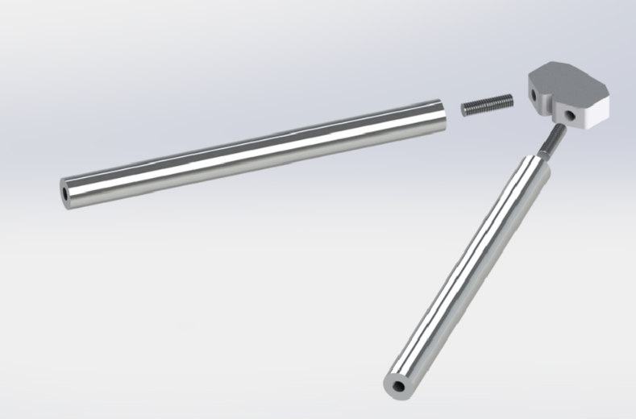
Figure 59: Components making up a wishbone.
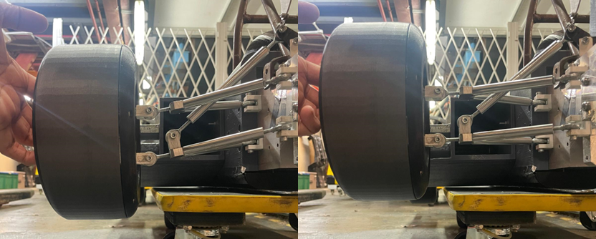
Figure 60: Comparison of Minimum Ride Height at minimum pushrod length (left) and maximum pushrod length (right).
Following this, the uprights and suspension mounts were manufactured. The uprights were water jet cut and CNC machined to achieve the intricate geometry of the design, with holes which we tapped in the workshop to accommodate the suspension mounts. The latter were cut from a length of U-channel profile aluminium, cut into thirty-two 12mm long pieces with holes drilled which had been predefined in the designs.
The purchased rod ends were easy to implement into the suspension design and were screwed into the threaded holes designed for them. They were secured onto the wishbone’s control arms with threadlock to prevent them coming loose during testing due to vibrations, as depicted in figure 61.
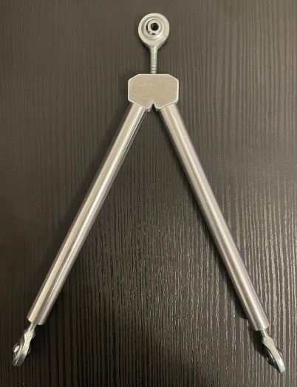
Figure 61: Completed assembly of wishbone with purchased rose joints.
However, an issue arose when attempting to mount the purchased rod ends onto the designed mounts due to compatibility issues, as we had designed these mounts to be compatible with rod ends from a different manufacturer. Upon consultation with Dr D. Marshall, a decision was made to 3D print a new batch of suspension mounts designed to perfectly fit our new rod ends. These were printed out of PLA with an 80% infill density to ensure structural integrity, as shown in figure 63.
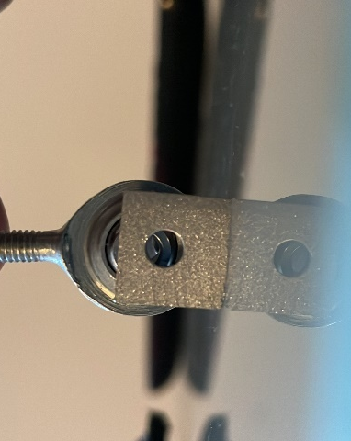
Figure 62: Manufactured metal U-brackets by EDMC which were too small.
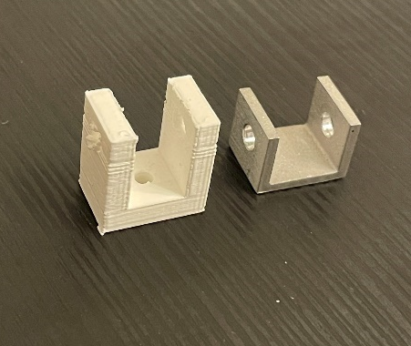
Figure 63: Side by side comparison between manufactured and printed U-bracket.
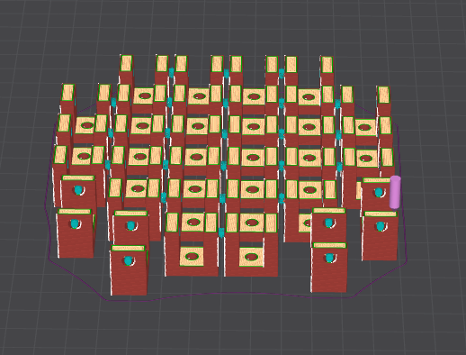
Figure 64: Print orientation of U-brackets.
The final components, the rockers, were 3D printed from PLA with an infill density of 60%. The rockers were designed to facilitate sufficient travel of the suspension system to enable the car to run at the desired ride heights. A high infill density was selected to ensure part strength, although these were not anticipated to endure high levels of stress, we wanted these parts to be durable as they are a moving part within the system.
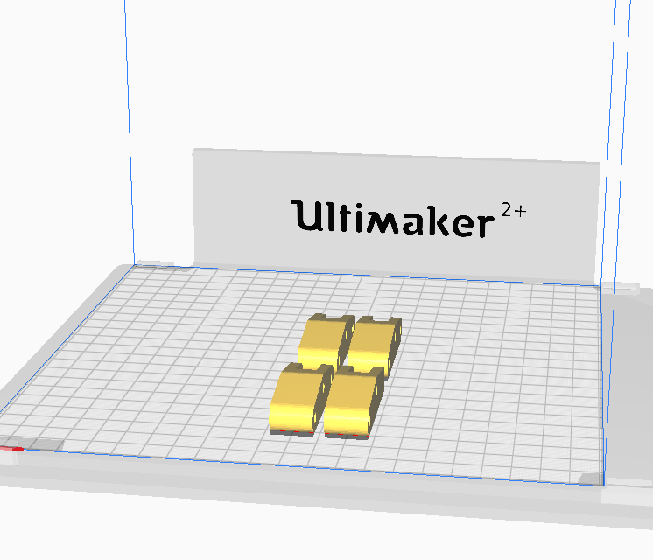
Figure 65: Print orientation of the 4 rockers.

Front Wing
The overall dimensions of the front wing which was designed for this year’s wind tunnel model had dimensions of 657.42mm x 274.05mm x 174mm. This meant that the whole front wing would not have fit into the 3D printer which was used. Therefore, the front wing was split into two halves and printed separately. The nose attached via pylons was also printed along with the front wing and had to be split in half as well. The two halves would then have to be assembled via friction fitting. The secondary wing element was not printed along with the main element to so that the angle of attack of the secondary element can be adjusted. This provides the team with mode data which can then be validated against data collected from CFD simulations.
Due to the complex geometry of the front wing which had very few flat and even surfaces, supports had to be added beneath the curved surfaces and overhang to enable the part to be successfully printed. The orientation in which the front wing was printed can be seen in Figure… below. The one half of the front wing took about 4.5 days to finish while using almost a whole roll of filament which was around 1kg.
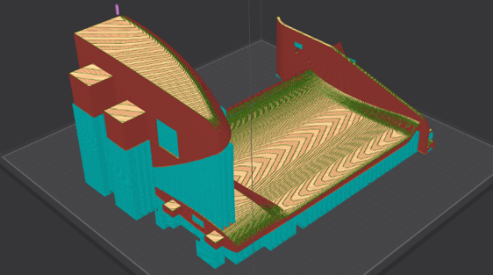
Figure 66: Print orientation of one half of the wing and nosecone.
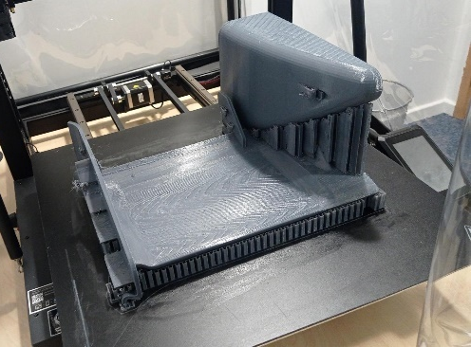
The printed half of the wing can be seen in figure 67. The supports were removed using a pair of snips which helped especially in removing supports from tight regions such as between the nose and the trailing edge of the main element. However, a rough surface was left behind when all the supports were removed which disrupts airflow over the front wing affecting the reliability of the data gathered from the wind tunnel test. These rough surfaces were smoothened using different grits of sandpaper starting with a coarse sandpaper of 40 grits and ending with a very fine sandpaper of 2000 grits. The result after sanding was a smooth aerofoil surface free from major surface irregularities, fit for wind tunnel testing.
Figure 67: 3D printed half of the front wing with nosecone.
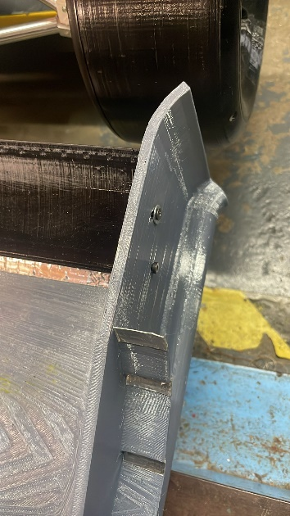
The secondary element with dimensions of… was printed separately from the main front wing. Slits and holes were made to the endplates so that the secondary element can be fastened onto the front wing and still allow a change in angle of attack. The secondary element was designed to have two holes on either side of the surface so that heat inserts can be inserted into the print using a soldering iron. This allowed the secondary element to be bolted onto the rest of the front wing instead of having to tape or glue it. The bolts can also be loosened to allow the change of angle of attack during wind tunnel testing.
Figure 68: Assembly of secondary element to the endplates of the front wing.

Sidepods
The sidepod which was designed for this year’s model had dimensions of 208mm x 314.09mm x 140.71mm which was within range of the print volume allowed by the 3D printer. This meant that the whole sidepod could be printed in one whole piece unlike the front wing. Four holes which lines up to the holes on the bodywork was made on the inner surface of the sidepod allowing a M4 bolt to fit through so that the sidepods can be secured to the rest of the bodywork and metal spine. The sidepods had more flat surfaces compared to the front wing and therefore, fewer supports had to be added to the surfaces.
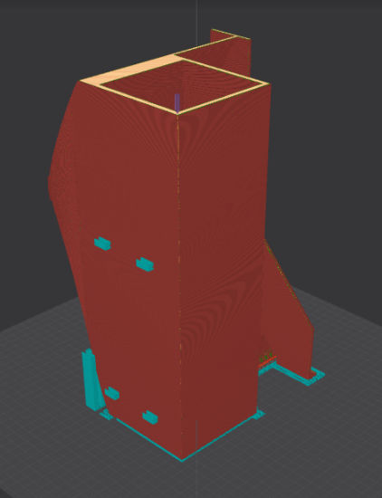
Figure 69: Vertical print orientation of sidepods
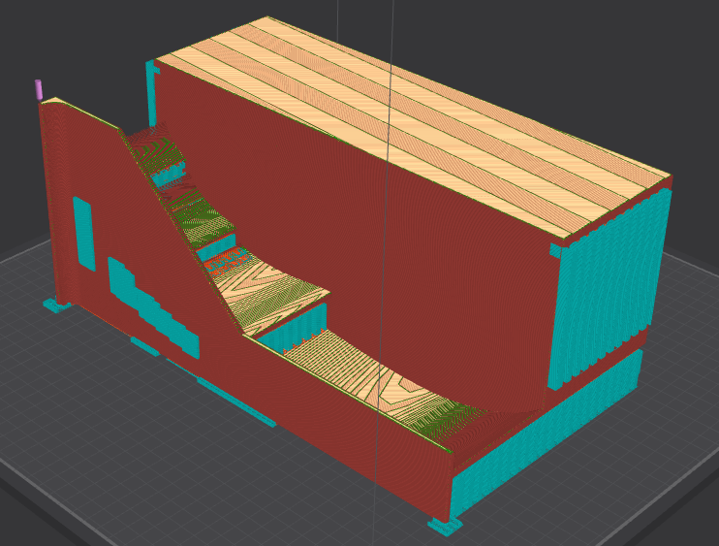
Figure 70: Horizontal print orientation of sidepods
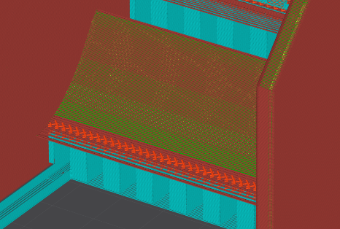
When slicing the CAD file of the sidepods in preparation for 3D printing, both the vertical and horizontal printing orientation of the sidepods were considered, figures 69 and 70 above. Although the vertical printing orientation required less material, print time, and less supports, the latter option was chosen when printing the first sidepod. This was because when using the slicer function on the 3D printing software, it was observed that the trailing edge of the aerofoils on the sidepods when printed vertically would only be made of a singular strand of filament which was very thin and fragile as seen in Figure…. There was a risk in damaging the trailing edge especially when removing the supports from underneath it. Hence, the safer but more time-consuming option which was to print the sidepod horizontally was selected.
Figure 71: Potential print issue at the trailing edge of the aerofoil.
However, due to time constraints and difficulties in removing the supports within the sidepod, the other sidepod was printed vertically in hopes that the trailing edge will remain intact after printing. Aluminium tape was used to reinforce the trailing edge of the aerofoils, preventing them from breaking off during wind tunnel testing. The surface finish of the sidepod which was printed vertically was much better than the sidepod which was printed horizontally due to the build orientation of the layers as well as the absence of supports which leaves a rough surface finish that must be smoothened when removed.

Bodywork
Each of the 9 different bodywork pieces were 3D printed individually with printing times ranging from… for the largest piece to… for the smallest piece. All bodywork pieces were printed with the same infill pattern and infill density set at 15% which was sufficient in maintaining the structural integrity of the part. Most of the bodywork parts had flat and even surfaces which meant that very few support structures were needed to successfully print the parts. Once printed, the individual bodywork pieces would be assembled ensuring that the parts were able to friction fit well with each other and the holes made on the bodywork aligned with the holes on the metal spine.
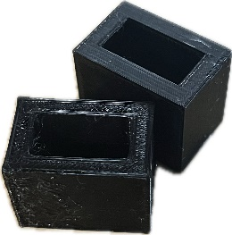
For the first few parts that were printed, the holes did align with the holes in metal spine but the friction fitted components were not able to fit with each other. To overcome this problem, smaller prints of the friction fitted components with some amount of tolerance factored into the dimensions were printed and tested on the other pieces as seen in figure 72. These tolerances in the dimensions were adjusted until a satisfactory fit where the components were not able to easily slide off when flipped was achieved. The desired tolerances were then factored into the dimensions of the rest of the friction fitted components.
Figure 72: Small test prints for friction fitted parts.
After all the bodywork pieces were printed, they were assembled onto the metal spine using M4 bolts to secure them in place. During assembly, some of the bodywork parts had to be slightly shifted because the holes were just slightly misaligned to the metal spine. This caused some of the other bodywork parts to not fit and these parts had to be filed down for them to fit into the assembly.

Model Assembly
After the completion of all the necessary components, the suspension system for each corner of the car underwent assembly and functional testing to ensure correct operation. The assembly procedure then began with the insertion of the wind tunnel balance into the spine, followed by the mounting of the chassis to enclose the balance within the car’s structure.
Subsequently, the diffuser was fixed to the car’s base, with the suspension following being attached to the newly drilled and tapped mounting points on the spine. With the fundamental assembly being completed, focus shifted towards the installation of the aerodynamic components of the package.
The aerodynamic elements were attached sequentially with the front wing being joined and securely bolted to the spine. Following this, the sidepods were fixed directly to the car utilizing long bolts which secured the sidepods directly to the spine.
The attachment of the rear wing involved using mounting blocks connected directly to the spine, supplemented by swan necks bolted onto the car’s roll hoop. The deliberate choice of bolting components onto the spine highlights the modular nature of this model, allowing convenient interchangeability for testing purposes as per our outlined objectives.
The assembly procedure is illustrated in figure 73 showing the process of assembling all components with figure 74 depicting the fully assembled model.
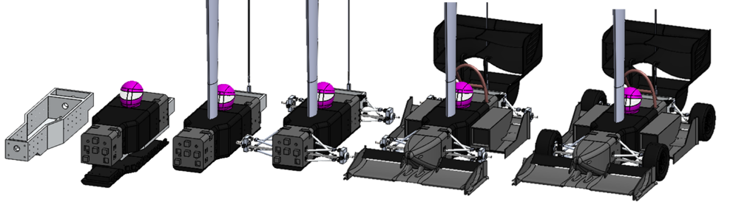
Figure 73 Assembly order of the wind tunnel model.
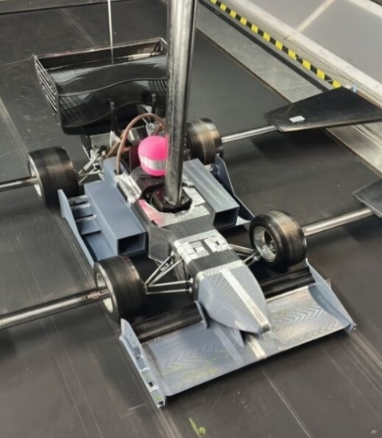
Figure 74: Fully assembled wind tunnel model

Challenges & Errors
Most of the challenges faced during manufacturing was during 3D printing with the most common issue of prints failing midway. This is because 3D printing is very temperature sensitive let alone using PETG as the filament material. Changes to the nozzle and print bed temperatures may result in layer adhesion issues or the under-extrusion of the filament. Initial layer print speeds which are too fast may also result in bed adhesion problems. Some of the challenges that were faced during the manufacturing phase can be seen in the figures below.
Figure 75 shows a failed print where the print shifted diagonally backwards mid-way through printing presumably due to a problem with sensors detecting the x and y axis movement of the print bed being misaligned with the actual location of the print bed. Figure… shows a bodywork piece that was fully printed but upon closer inspection, some of the layers showed signs of delamination due to low adhesion with the previous layer. Delamination decreases the strength of the part and the section where delamination occurred broke off not long after during assembly. Other issues with the prints included failed prints where the first few layers were printed but for the subsequent layers the print would just fail and produce a web of extruded filament which was spread all over the print bed as seen in Figure…. This could be because of various reasons such as incorrect printer settings which result in the under extrusion of the filament. In another print which failed, the loose end of the filament was found to be looped around itself (Figure…) which then generates tension in the filament as it being pulled and extruded by the nozzle resulting in filament being under extruded during printing.

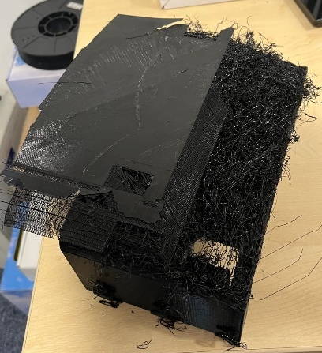
Figure 75: Failed print where print bed shifted.
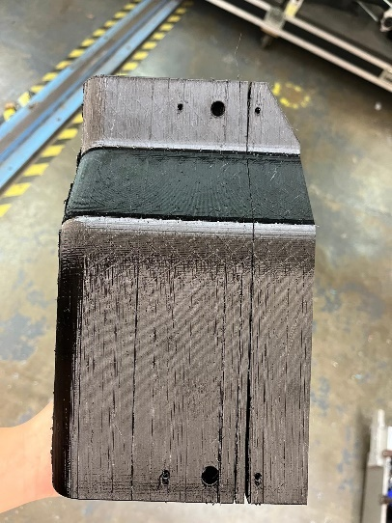
Figure 76: Delamination in printed parts.
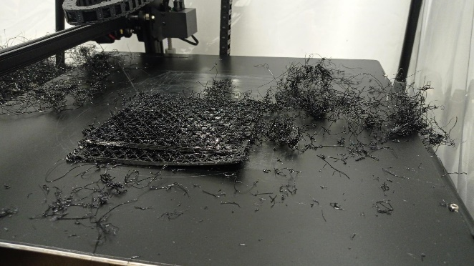
Figure 77: Failed print where the extruded filament scattered across the print bed.
A further challenge we faced was that the supplied wheel load cells differed from the designs that were present in the CAD provided to us by the previous year’s group. This caused long delays in the manufacturing process as we had to redesign the required load cells and sent them to be manufactured by the EDMC during their busiest period. This left us waiting for several weeks before we could make progress in the final assembly of the suspension system.
Unfortunately, time constraints stopped us from manufacturing the designed steering control arms necessary for steering angle control. This prevented us from running yaw tests as part of our wind tunnel test plan.

Wind Tunnel Testing
Three days of wind tunnel testing was done in the university’s RJ Mitchell Wind Tunnel from the 15th to 17th of April 2024 to validate the design of our wind tunnel model with the CFD results.

Day 1 – 15th APRIL 2024
The aim of the first day of wind tunnel testing was to mount the wind tunnel model to the balance in preparation for tests to be run the following day.
A week prior to the wind tunnel testing dates, the team was finishing up on 3D printing the last few parts required for the wind tunnel l model while concurrently preparing the rest of the printed parts, making sure that they fit well with each other on the metal spine. All the bodywork and aerodynamic parts were 3D printed before the wind tunnel testing dates to ease the assembly of the whole model on the day. The suspension parts manufactured by EDMC were also received and assembled beforehand. All the bodywork, aerodynamic parts and suspension were bolted onto the metal spine with some parts being further reinforced via friction fitting.
The first challenge arose when the team was trying to fit the internal balance inside the spine of the model. The internal balance which was provided and used by the wind tunnel is an Aerotech 6-component balance where the output signal from the balance is sent to a National Instruments Compact RIO realtime controller. The bodywork that was designed was based around CAD files provided from last year’s model which showed that the internal balance was able to fit within the metal spine. However, when the internal balance was placed into the chassis of this year’s model, the height of the bodywork that goes around the spine was found to be too short and was unable to cover up the internal balance. This is contradictory to what was seen on the CAD files and therefore minor modifications had to be made to certain pieces of the bodywork, opening enough room for the internal balance to fit. Once fitted and mounted onto the spine, the internal balance was then mounted via the support sting and tail. The rest of the bodywork pieces were then fitted onto the spine and any wiring connecting the balance to the wind tunnel was hid within the bodywork to reduce vibrations and errors to the gathered data. This was followed by the fastening of the rest of the aerodynamic parts and suspension. The gaps in between the individual bodywork pieces were covered up with aluminium tape to prevent them from affecting the wind tunnel test results.
The team worked tirelessly and tried to finish the assembly of the model to the sting to maximise the remaining time for wind tunnel testing. However, at the end of the day, the model was not fully assembled due to the modifications that had to be made to the bodywork to fit the internal balance inside the spine of the car. The only remaining parts not fitted onto the car were some of the suspension and wheels which would be fastened on the morning of the second day of testing. The progress for the first day can be seen in figure 78 below.
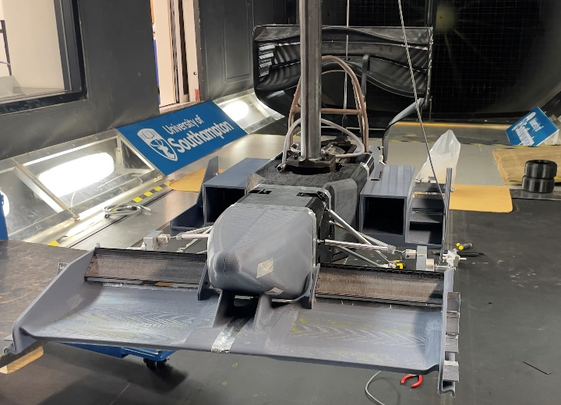
Figure 78: Progress on the assembly of the physical model at the end of day 1.

Day 2 – 16th April 2024
The second day started with the team arriving early at the wind tunnel to continue setting up the rest of the suspension. That was when we faced our second challenge due to time constraints as a result of the challenges faced on the initial day of testing, we were unable to manufacture the steering control arms necessary for keeping the wheel fixed during testing. This meant that if we were to do wheel-on testing on the current model the wheels would have been moving around during the test due to the forces asserted by the incoming wind. This would affect the accuracy of the data obtained from the wind tunnel test. Thus, a decision had to be made on whether to persist and find a way to fix the tire in place or to make a compromise and do wheels-off testing instead.
After a brief consultation with Dr Renan from the wind tunnel, we proceeded to do wheels-off testing for our model due to time pressure and the fact that the data obtained from wheels-off testing will be like that of wheels- on testing. The only compromises were that we would not have been able to test our modular suspension system which was one of the key areas where we wanted to improve from the project last year and that the wheels were not the ones we were initially planning to use. With heavy hearts, we removed the wheels and upright from the model and proceeded with setting up for wheels-off testing as seen in figure 79.
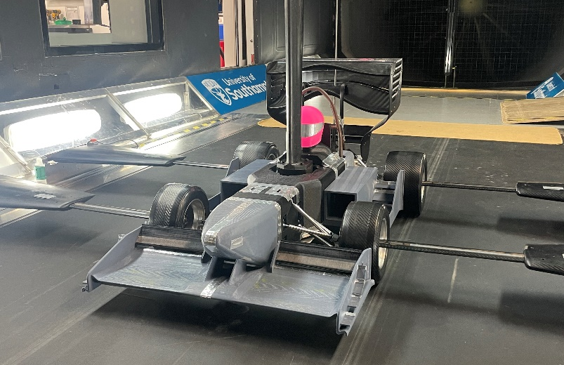
Figure 79: Setup of wind tunnel model for wheels-off test.
By midday, the model was fully set up for wheels-off testing. The main difference of wheels-off testing from wheels-on testing is that the wheels are not connected to the suspension system for wheels-off testing. Instead, they are just held in place by four external supporting arms. 3 main tests were conducted. First was a heave test. The car was run at many ride heights ranging from 15 to 45 mm. Next was a pitch test where the front ride height was set to first 25 and the rear adjusted incrementally from 25 to 45 mm. This was then repeated at a front ride height of 30 mm. Lastly, a change in angle of attack test on the second element was conducted for the specified ride height map above. The test started at an angle of attack of 20° and ended at 50° with increments of 5° after each run.
The software which was used to run the series of planned tests was an in-house developed National Instruments Labview system which allows a script to be ran sending the model through different ride height maps and at specified tunnel conditions. The data gathered was then passed to an Access database file where it was extracted and subsequently analysed.

Day 3 – 17th April 2024
The aim for the final day was to conduct a smoke visualisation test and apply Flow-Vis on certain aerodynamic parts of the car to observe the flow structure and boundary layer separation occurring on these elements respectively. The smoke test was done with a smoke machine which was fitted with a smoke wand. The wind tunnel was set to a moderate speed of 5m/s and the smoke wand was positioned at various points on the aerodynamic surfaces of the model to visualise the formation of the flow structures as the smoke hits the surfaces as seen in figure 80.
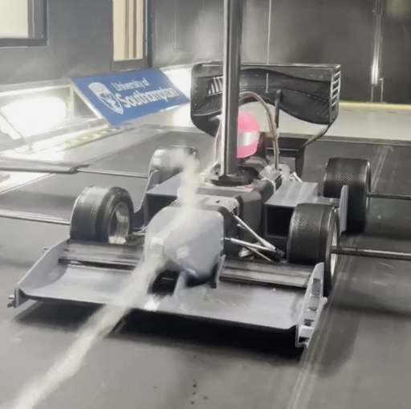
Figure 80: Flow visualisation test using smoke from a smoke gun.
Flow-Vis was applied to the second element of the front wing as well as the sidepods to see the direction of the flow and the location where the boundary layer separation occurs. An ultraviolet light was then used to enable us to better visualise the results of the test. Upon inspecting the results, the team noticed that the paint that was used was getting trapped along the textures on the surface because of the manufacturing methods used which was 3D printing. This can be seen in figure 82 below.
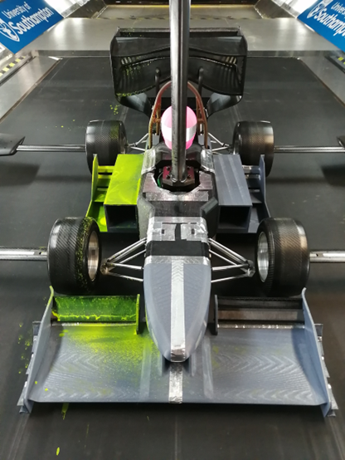
Figure 81: Flow-Vis paint applied to the model for flow visualisation.
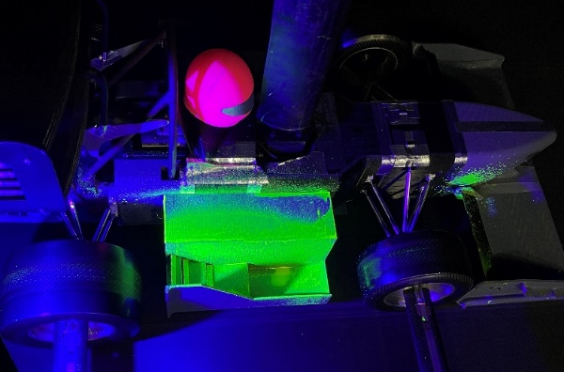
Figure 82: Flow-Vis paint applied to the sidepods seen under ultraviolet lights.
In an effort to test the suspension system that our team spent so much time and resources designing and manufacturing; our team came up with a solution that would temporarily lock the wheels in place for wheels-on testing. This was to prove and validate the design of the new suspension which was one of the key areas that the team wanted to improve from last year’s project. The team used some washers to fix the rose joints which were connected to the upright in place which then prevents the wheel from moving. This was done to all the rose joints connected to the uprights on all 4 wheels as seen in Figure…. With the wheels secured in place, the team decided to give wheels-on testing a go at wind and road speeds of 10m/s. The same ride height tests were done with the secondary element of the front wing set to 35 degrees. While the test was running, the team observed that the wheels were not rotating at the same speed and upon further inspection it was found that the bearings fitted in them were not spinning smoothly. This caused the inconsistent rotation of the wheels as the test was ongoing. Despite this challenge, the suspension held out throughout the whole test and the team managed to validate the new suspension design across a range of ride heights.
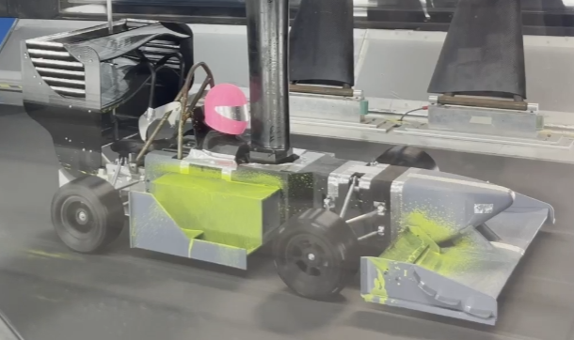
Figure 83: Wheels-on testing.
After three long days of wind tunnel testing, the team managed to collect enough data which can be then validated with the data obtained from CFD simulations. A test matrix for the 3 wind tunnel testing days can be seen in table 8 below. The team also managed to validate the design and functionality of the new suspension system. All in all, a successful three days of testing given the challenges and compromises made throughout the test.
Table 8: Test matrix wind tunnel testing.

Validation (CFD and Model)

Domain Setup
A key goal of this project is to validate the CFD simulations using a wind tunnel model. To achieve this, the model and its boundary conditions must be constructed made in CFD to validate against. The CFD model designed in this project is for a full-scale FS car whereas, the wind tunnel model is a 40% scale of this. An additional CFD workflow was developed, importing the geometry of the RJ Mitchell WT as the domain, to correctly model the blockage ratio of the WT model. The domain was scaled to 250% of the original scale, including the boundary layer, to accurately capture the boundary layer interactions. To maintain Reynolds scaling, the velocity of the freestream in the validation CFD was set to 40% of the WT test speed. Figure 83 shows an image of the domain used for validation.
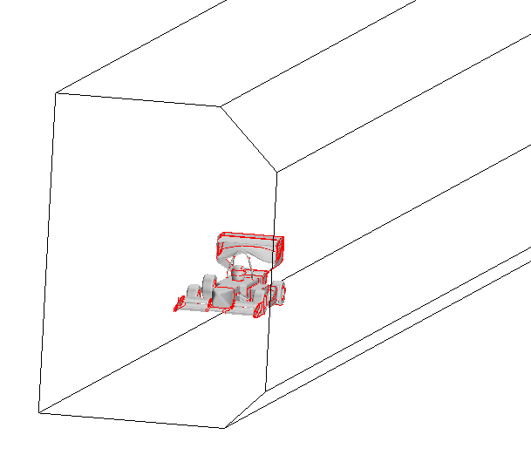
Figure 84: CFD domain setup.

Results
Below is the comparison between the WT and CFD results for the tests that were conducted. For the pitch data, only the runs with 25 mm front ride height are plotted. As expected, there is an offset between the CFD and WT results. However, both sets of downforce datum have an average percentage error of 20% and follow the trend of the WT data which is good. The main problem comes with the drag in pitch. It does not follow the same trend as the wind tunnel result which does cause some concern.

Figure 85: Graph of lift coefficient, SCL against different ride heights in heave test.

Figure 86: Graph of drag coefficient, SCD against different ride heights in heave test.

Figure 87: Graph of lift coefficient, SCL against different ride heights in pitch test.

Figure 88: Graph of drag coefficient, SCD against different ride heights in pitch test.
Below are the results for the front wing tests. The results for these are less optimal. However, this is likely caused by the were lots of meshing errors when trying to validate these runs. More time would need to be invested into creating more refined CAD to be able to use this data for validation. However, the wind tunnel results do follow the expected trend and therefore there has still been a good dataset created by having an adjustable front wing on the wind tunnel model which was one of the objectives of this project.
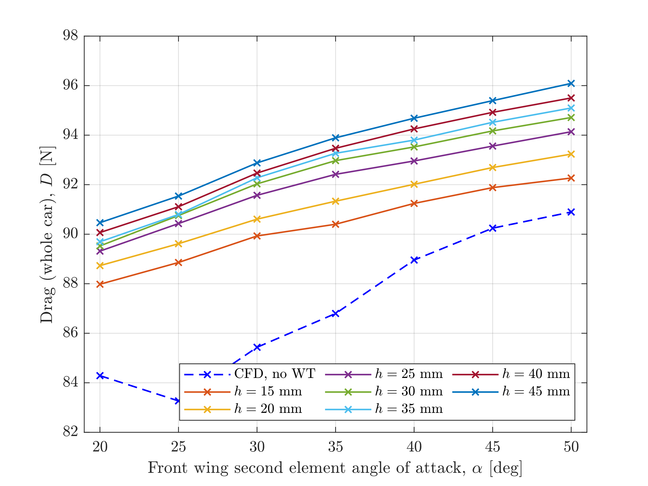
Figure 89: Graph of drag of wind tunnel model against different second element angle of attack at different ride heights.

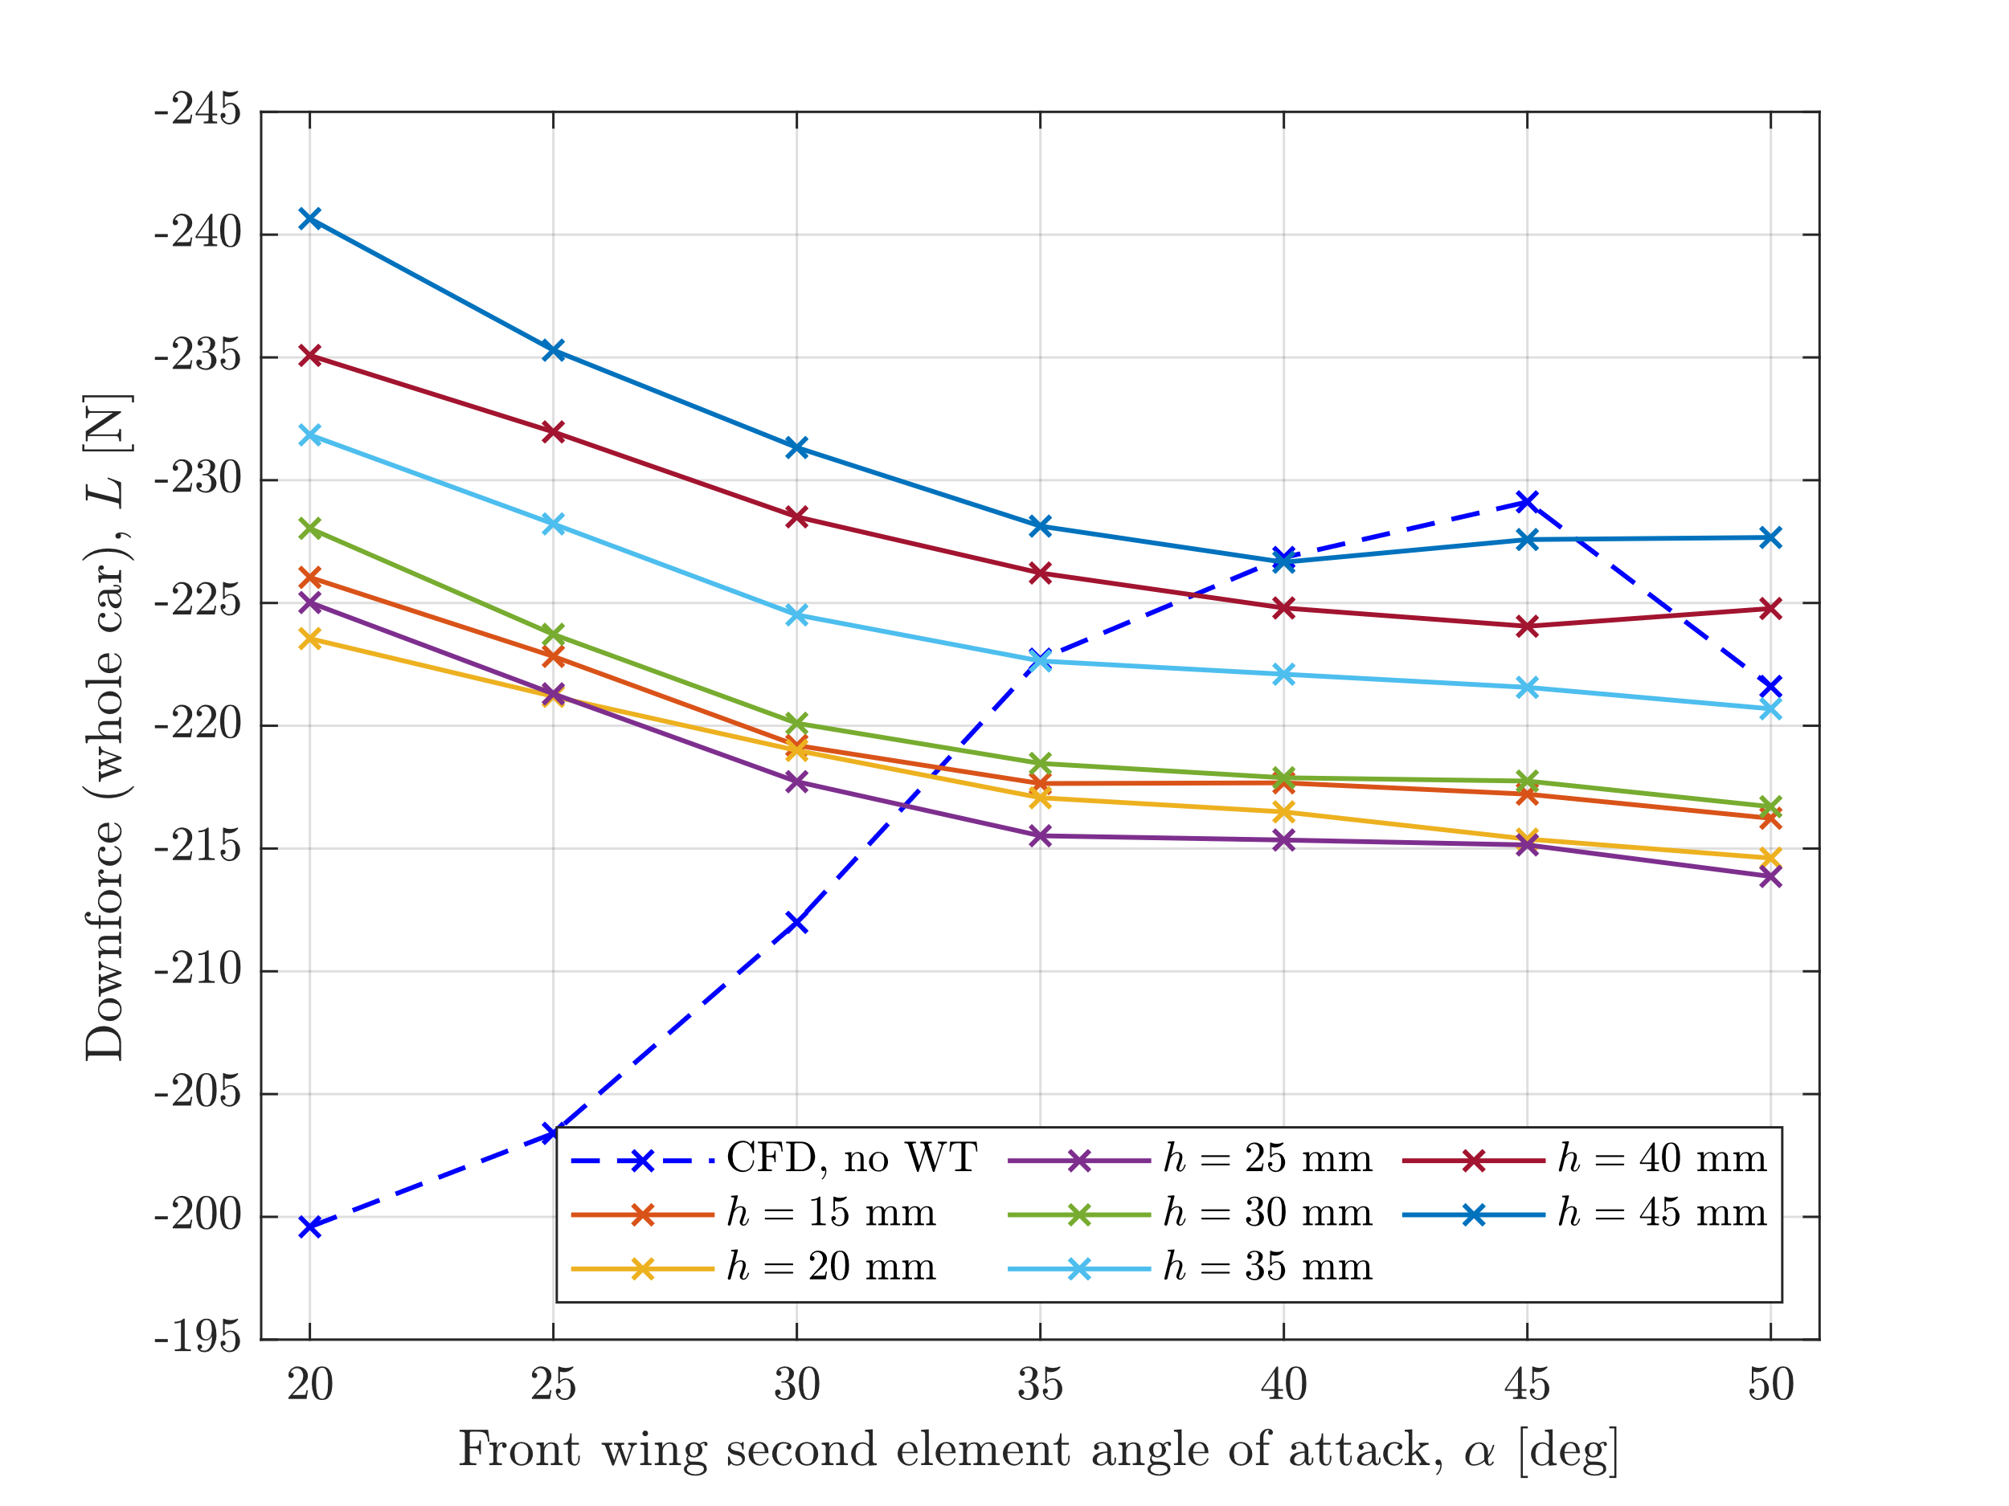
Figure 90: Graph of downforce of wind tunnel model against different second element angle of attack at different ride heights.

Comparison to 2023 model
The final thing to do is to compare between these results and last year’s.

Figure 91: Graph of comparison between the aerodynamic performance of the current 2024 and previous 2023 wind tunnel models.
The design this year has achieved the performance goal that was set at the start of the project. The final difference in lap time between the 2 designs was 0.2s in a single lap performance test and the gains would be extremely high over the course of the endurance test.

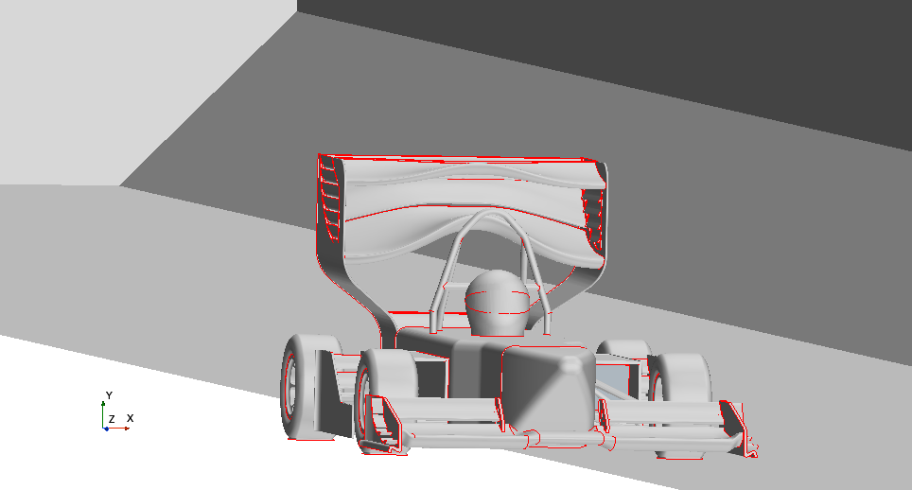
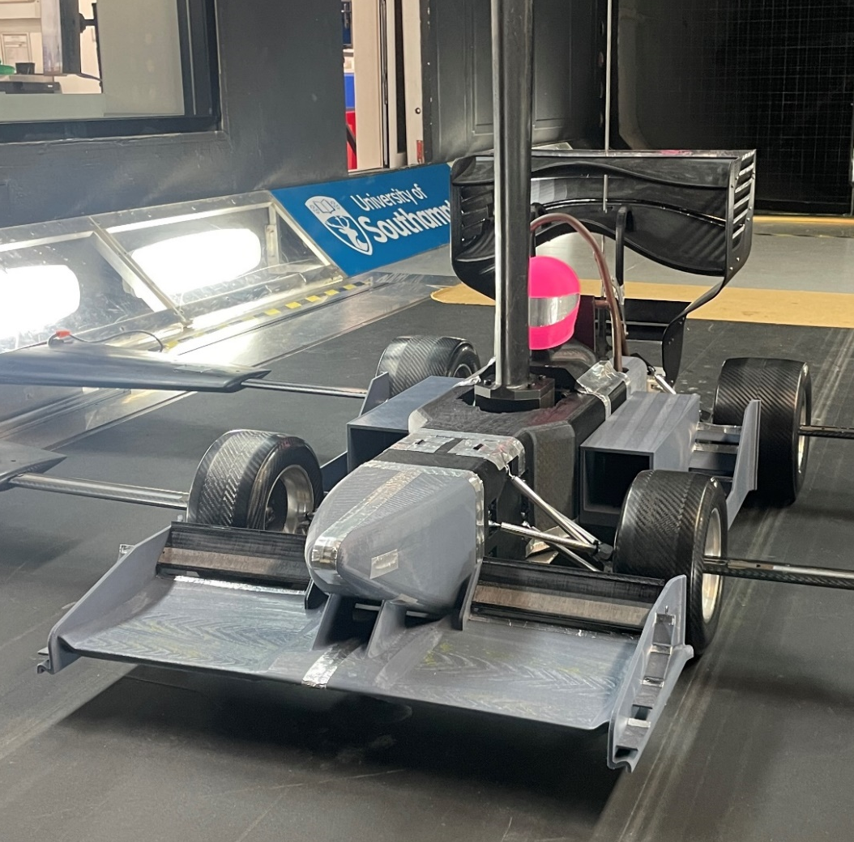
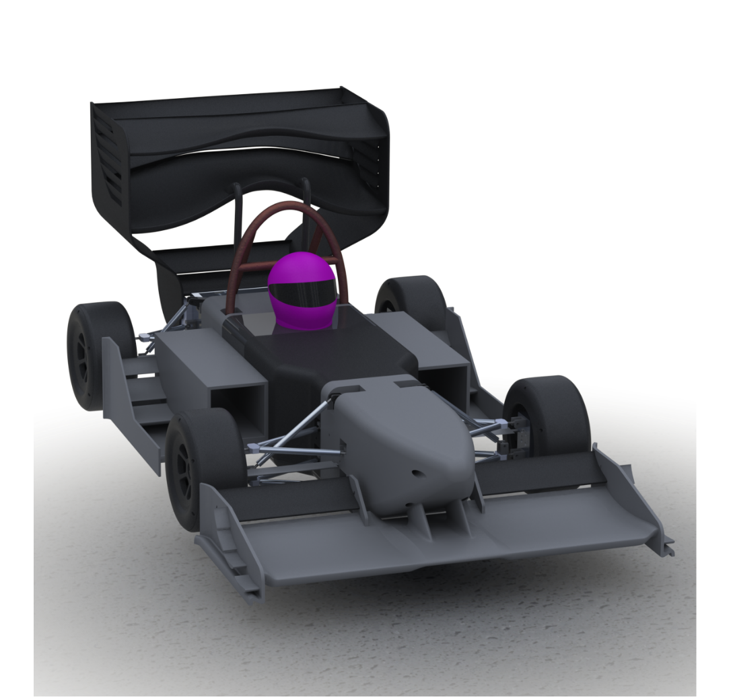
CAD Model
The CAD model was created in accordance with the legality boxes stated in the FSUK regulations. The aerodynamic model follows the design characteristics of a BEV which prioritises a high efficiency configuration. The model serves as a base where aerodynamic components can be designed, assembled, and changed based on data gathered. The CAD model is used in the CFD workflow model where data from simulation can be gathered. The assembly of the model also guides the manufacturing of wind tunnel model and the informs the subsequent model assembly.

Final Design Proposal
CFD Workflow Model
The custom CFD workflow model has undergone rigorous validation and correlation against existing literature as well as conducting checks for mesh and domain independence. These measures instil confidence in the CFD model’s ability to produce accurate and consistent data from simulation which is then used to highlight regions for improvement on the aerodynamic CAD model. The data gathered using the CFD workflow model also validates the wind tunnel test data gathered from the wind tunnel model.
Wind Tunnel Model
The wind tunnel model manufactured and assembled referring to the CAD model has freely rotating wheels and a moving suspension which allows more accurate data to be collected during wind tunnel testing. The model is modular in nature allowing parts to be swapped and adjusted for different test designs and configurations. The model is also durable and allows for repeated testing generating consistent results. The wind tunnel data validates the accuracy of the CFD simulations informing that the domain and mesh independence are accurate giving confidence in the results generated by the CFD workflow model.

GDP Review

Aims and Objective
We have achieved many of our objectives for this project. The car performance has met the criteria which we set at the beginning of the project. A new suspension design was manufactured that allowed for easy switching between wheels on and wheels off testing. We made a more comprehensive data set than before. We successfully created a modular bodywork design which can be used by future owners of the model to adapt their own designs onto the model and test.
The CFD is not as well correlated as would have been preferred and there was still a hope to have even more data, but the project ran out of time and resources to do this.

Innovation
Our team has undoubtedly demonstrated innovation for the entirety of the project, where each team member has their strength and is adept and proficient in a certain field. We have developed novel features for the front wing, as well as a brand-new bodywork and sidepod design. The suspension system is also sophisticated and able to function properly when needed. We also experimented with different orientations of 3D printing to gain insight into the printer's behaviour to minimise failed prints in the future.
Nonetheless, being quick-witted and thinking outside of the box also helped advance our progress, since unforeseen problems arise and ad hoc solutions are applied to mitigate the issue. For instance, the team faced a problem where the bodywork did not sit perfectly while accommodating the load cell. We hastily modified and adapted the bodywork geometry, or else the wind tunnel experiment would not have successfully taken place in time.

Implications of Design Process
Given that the aerodynamic package on last year’s model was well developed, the task of improving and upgrading areas of the model to extract more performance from it was quite challenging. Therefore, it was of utmost importance that a coherent design process was established and followed throughout the entire project. A skills matrix was created and filled by each team member to identify the strengths and interest of each member in specific tasks related to the project. This is to ensure that the tasks were divided equally among the members gauging their interest and proficiency in the tasks. A thorough project plan was also created to map out milestones of the project as well as set deadlines for the specific tasks.
The design process was then implemented which included a review of data from the previous year’s model, an in-depth research and literature review on Formula Student rules and regulations as well as race car aerodynamics, designing new bodywork and aerodynamic parts, running CFD to simulate the performance of the new parts, optimising the new parts, manufacturing all the optimised parts for the final model for assembly and wind tunnel testing. This vigorous process of designing and optimising the performance of the designed parts using data gathered on CFD enabled the team to extract the most performance from each of their parts. This resulted in the improvement and development of certain areas of the car (i.e. the bodywork and sidepods) as compared to the previous model.
Once the design was finalised, the parts were manufactured and assembled, the model was tested in the university’s wind tunnel to collect data from the wind tunnel model to validate the pre-existing data from the CFD simulations ensuring that both sets of data correlate to each other with minimal error between them.

Communication
Good communication between group members is the backbone of any successful group project. The ability to effectively communicate ideas and provide constructive feedback is key to ensure that the project runs smoothly and successfully. Our group constantly had both physically and virtually among ourselves and with our supervisors which were used to share progress updates, brainstorm ideas, and troubleshoot problems. Having frequent meetings ensures that everyone remains on the same page regarding project goals, timelines, and responsibilities. Feedback from both our supervisors and team members were also taken in positively which helped refine designs and processes. A Microsoft Teams group was also set up so that files could be exchanged especially when different members working on different parts must collaborate to ensure the parts designed fit well with each other. Other forms of communication include a WhatsApp group where meetings times and updates were shared.
This report is also structured in a way which outlines the design process that was followed from the beginning of the project until the end in chronological order. It also highlights the thought process and key decisions that were made by the group when designing, simulating, and manufacturing each part of the model ensuring the success of the project in achieving its key objectives. To effectively communicate our ideas to the reader, visual aids such as CAD renderings, images and graphs were added, referred to and explained in the report.

Sustainability
Sustainability stands as one of the core principles guiding our every decision. The team recognises the importance of minimising material waste and have implemented several strategies to make the project as sustainable as possible. As this is a project which was continued from the previous year, some of the parts such as the metal spine, diffuser, roll hoop and rear wing were reused from the previous model, minimising the need to remanufacture these parts hence minimising material waste.
Furthermore, our choice of using PETG to print the bodywork pieces and aerodynamic parts also embodies our dedication to sustainability. PETG is not only durable and lightweight but also readily recyclable ensuring that at the end of its lifecycle, it can be repurposed to make recycled PETG 3D printing filament rather than being discarded [18]. These parts were also bolted and fastened to the metal spine, minimising the use of tape and glue. This not only enhances the structural integrity of the model but also simplifies disassembly and maintenance for further upgrades to be implemented. By reducing reliance on adhesives, the environmental impact can be reduced and recyclability is promoted.
In line with our commitment to sustainability, the wind tunnel model was designed to be modular enabling the interchangeability of different parts of the model. Thus, the need to manufacture new components when a part needs to be replaced is reduced which not only saves time and resources but also reduces waste generated. The team also conducted comprehensive CFD simulations prior to the manufacturing of the wind tunnel model for wind tunnel testing. The CFD model that was used is an improvement from the CFD model used last year. This initiative not only conserves resources and reduce energy consumptions but also optimises the design iteration process leading to a more efficient and sustainable final product.
The wind tunnel model was designed and built at a 40% scale and was tested in the RJ Mitchell wind tunnel. However, the model can be also tested in the 7’ x 5’ wind tunnel which is smaller than the RJ Mitchell wind tunnel. Testing in the smaller 7’ x 5’ wind tunnel will lead to large overall energy savings as the power consumption for the 7’ x 5’ wind tunnel is 120kW compared to 550kW for the RJ Mitchell wind tunnel. This may seem insignificant but over a three-day testing period, the total overall energy saved would be substantial.

Critical Review
The decision to not revise and explore upgrades to the rear wing and diffuser may have been a missed opportunity to potentially enhance the model’s overall performance as both elements may have big impact to the overall aerodynamics of the model. Failure to maximise the entire budget with £149.05 remaining may also have been a missed opportunity to invest in higher quality materials and manufacturing techniques which may have improved the overall surface finish of the car yield small gains to the overall performance of the car.
The wheels that were used for wheels-on wind tunnel testing were also found to be faulty and inconsistent. The bearings that were fitted into the wheels were not equally smooth for all four wheels and the surface of each wheel was also found to be uneven. This may pose issues regarding the validity of the data collected from wind tunnel test as defective wheels introduces unnecessary variables that may distort the collected data. Failure to manufacture steering arms to control and fix the directions of the wheel due to time constraints resulted in wheels-off testing being done instead of the desired wheels-on testing. Data gathered from wheels off testing may be very similar to that of wheels on testing but may not directly represent real world conditions which may lead to misleading results.

Future Works
While significant progress has been made, there is potential for continued growth and enhancement in various aspects of the project. The WT model has successfully met most of the initial goals for lift, drag, and %FR, but it is important to recognise that there are still numerous areas for further development and improvement.

CFD
Computational fluid dynamics simulations are imperative to validate experimental data and spot any design flaws during the iterative design process. However, there are some shortcomings. One promising opportunity for improving CFD is the exploration of multiphysics simulation, integrating the disciplines of aerodynamics and thermodynamics to provide a comprehensive understanding of fluid behavior within the vehicle's environment. Leveraging advanced tools like COMSOL, this approach aims to quantify cooling effectiveness by analyzing the intricate interplay between airflow and thermal dynamics, offering valuable insights into heat dissipation mechanisms. Furthermore, to accommodate increasingly complex simulations, there is a pressing need to run CFD models on higher specifications. This will result in more detailed simulations with greater efficiency and accuracy. Moreover, efforts to improve the overall run quality of CFD simulations are imperative. Despite advancements in simulation methodologies, instances of random failures persist, posing challenges to consistency and reliability. Addressing these issues demands a concerted effort to identify and rectify underlying causes, ensuring robustness and predictability in CFD results.

Manufacturing
To prevent print failures form occurring on future work of similar kind, small test prints should be initially made to identify the most optimised set of printer settings for the specific 3D printer and 3D printing material used. This will help reduce the frequency of print failure and problems such as delamination from occurring which will help reduce time and material wastage. The most optimised print orientation that contains the least number of overhangs on the print should also be selected to reduce the required supports.
3D printed parts have relatively poor surface finishes. Therefore, to improve the surface finish of 3D printed parts, one can consider post processing methods such as sanding using different grits of sandpaper, polishing using metal polishes such as Brasso, or even heat treating the surfaces using a heat gun which melts away a thin layer of the print surface. Other methods such as applying an epoxy coating or using a solvent to dissolve the surface layer can also be used to improve the surface finish but these methods involve the use of chemical substances which will have a negative impact on sustainability.
Other manufacturing methods such as injection moulding and casting can also be explored to manufacture the bodywork and aerodynamic parts. Injection moulding and casting is suitable for producing complex custom parts with high dimensional accuracy. Injection moulding and casting also produces parts with excellent surface finish minimising the need for post processing. Replacement parts can also be manufactured with high repeatability at low cost.
One area that could potentially be improved is the further development of the wheels. One could design and fabricate a set of wheels with rubber treads and grooves to provide better traction on the conveyor belt and prevent slip, while complying to the FS regulations. Better bearings could also be fitted onto the wheels while also constantly lubricating them ensuring that they would not get jammed and affect the ability of the wheel to spin smoothly.

Materials
The car model has been extensively manufactured using fused deposition modelling (FDM), which is an additive manufacturing (AM) method, because it is one of the fastest and most economical way to do so. The material used in such manufacturing is PETG, which is a thermoplastic with high chemical and impact resistance. However, the printing quality is not so ideal since there is frequent voids, delamination, and bad surface finishes in the print. For the future work, one could explore other viable materials such as PLA and ABS.
In addition, one might want to consider using other family of materials such as carbon fibre reinforced polymer (CFRP) for bodywork monocoque and titanium alloys for the suspension or other small and fragile parts. Also, software such as Ansys Granta EduPack allows one to do a global material search and apply design requirements to narrow down the scope.

Active Suspension
Although the current model’s suspension system has been significantly improved from the previous model, there still room for improvements for future designs. One aspect of the suspension which could be further explored is the integration of an active suspension. Having an active suspension allows for real-time adjustment of ride heights and damping characteristics due to the oscillation of the wheels during testing. This will also reduce the time taken to transition between different model test conditions. Another aspect of the suspension that can be improved is the inclusion of an actuated steering mechanism which allows the precise control over the orientation of the front wheels. Having an actuated steering mechanism facilitates more accurate simulations of on-track handling dynamics during wind tunnel testing. Enhancing the current suspension system with the mentioned initiatives will better equip future wind tunnel models to deliver more comprehensive and reliable data from wind tunnel testing.

Active Aerodynamics
The model's aerodynamic performance can be improved by improving the design and implementing active aerodynamics. This can be done by adding additional aerodynamic features such as turning vanes to the front wing. While retaining the rear wing from the previous year provides a foundation, there is potential for further advancements in this component. Moreover, microcontrollers or actuators can be used to adjust the front and rear wing angles. Additionally, integrating advanced technologies such as Drag Reduction Systems (DRS), actuators, and electronic control systems offers an opportunity for precise management of aerodynamic elements during different driving conditions.

Conclusion
To conclude, the project achieved its aim by increasing the robustness of the wind tunnel model while increasing the aerodynamic performance of the design. The project used iterative design to create a high performing package that followed a clear design philosophy based around the uniqueness of a BEV. Successful development and validation of performance measure tools like CFD simulations lead to sound package development in a time and budget restricted project. Development of a new front wing, sidepod and bodywork in a cohesive and innovative way produced a package performance that exceeded the projects targets. The projects final design had 90% of the downforce as the previous design with a lower drag coefficient and produced almost the same lap time. Meanwhile, it can adequately cool itself to perform to a high standard in the endurance event. A modular wind tunnel was designed, manufactured, and tested showing excellent repeatability as was the aim. The final design proposal consisted of 3 distinct outputs: an aerodynamic package, a modular wind tunnel model, and a validated CFD model.

References
- Institution of Mechanical Engineers, “About Formula Student,” iMechE, 2024. [Online]. Available: https://www.imeche.org/events/formula-student/about-formula-student. [Accessed 02 04 2024]
- Institution of Mechanical Engineers, "Surge in electric and autonomous vehicles at Formula Student 2020", https://www.imeche.org/news/news-article/surge-in-electric-and-autonomous-vehicles-at-formula-student-2020 [Accessed 02 04 2024]
- Institution of Mechanical Engineers, “Formula Student Rules, Formula Student 2024 Rules,” 2024. [Online]. Available: https://www.imeche.org/events/formula-student/team information/rules. [Accessed 02 04 2024]
- X. Zhang, W. Toet, & J. Zerihan, Ground Effect Aerodynamics of Race Cars. 2006, https://doi.org/10.1115/1.2110263
- University of Southampton, “R.J. Mitchell tunnel,” [Online]. Available: https://www.southampton.ac.uk/windtunnels/facilities/rjmitchell.page. [Accessed 07 04 2024]
- University of Southampton, “7' x 5' tunnel,” [Online]. Available: https://www.southampton.ac.uk/windtunnels/facilities/7x5tunnel.page. [Accessed 07 04 2024]
- “Formula student,” Previous events, https://www.imeche.org/events/formula-student/previous-events [Accessed 12 04 2024]
- Fotouhi, A. (n.d.). Formula-E race strategy development using artificial neural networks and Monte Carlo tree search. Neural Computing and Applications, 32. https://doi.org/10.1007/s00521-020-04871-1
- Battery Thermal Management in Formula E - Canopy Simulations. (n.d.) Available https://canopysimulations.com/2018/03/06/battery-thermal-management-in-formula-e/ [Accessed 18 04 2024]
- T. X. Xie, “Applications of CFD - Reynolds-Averaged Navier-Stokes equations - Lecture 4.2,” in University of Southampton.
- M. Halkiopoulos, “MC12027/openlap-lap-time-simulator: Open source lap time simulator coded in Matlab.,” GitHub, https://github.com/mc12027/OpenLAP-Lap-Time-Simulator [Accessed 20 04 2024]
- F. Jander, “Designing a Formula SAE electric cooling system,” Designing a Formula SAE Electric Cooling System, https://www.filipjander.com/2020/09/designing-formula-sae-cooling-system.html [Accessed 20 04 2024]
- Anon. “How to simulate radiator, fan, and duct in STAR-CCM+ and design suggestions”. siemens.com. Available https://community.sw.siemens.com/s/article/How-to-simulate-radiator-fan-and-duct-in-STAR-CCM-and-design-suggestions [Accessed 22 04 2024]
- T. Polygenis “PETG vs PLA: Differences and Comparison” wevolver.com 2023. Available https://www.wevolver.com/article/petg-vs-pla-how-do-they-compare [Accessed 20 04 2024]
- J. O'Connell,Glass Transition Temperatures of PLA, PETG & ABS. Available https://all3dp.com/2/pla-petg-glass-transition-temperature-3d-printing/ [Accessed 20 04 2024]
- “Team Xometry”, “PETG vs. PLA: Differences and Comparison” xometry.com 2022. Available https://www.xometry.com/resources/3d-printing/petg-vs-pla-3d-printing/ [Accessed 20 04 2024]
- B. O’Neill “Cura Infill Patterns: What They Are and When to Use Them” wevolver.com 2024. Available https://www.wevolver.com/article/cura-infill-patterns [Accessed 23 04 2024]
- Bremer, M., Janoschek, L., Kaschta, D. et al. Influence of plastic recycling—a feasibility study for additive manufacturing using glycol modified polyethylene terephthalate (PETG). SN Appl. Sci. 4, 156 (2022). https://doi.org/10.1007/s42452-022-05039-3

Appendix

Skills Matrix

Gantt Chart

Cost Breakdown

Part Description | Manufacturer/Supplier | Quantity | Price Per Item | Total
Suspension
M4 Rose Joints LH Thread | McGill Motorsport | 4 | £ 6.60 | £ 26.40
M4 Rose Joints RH Thread | McGill Motorsport | 28 | £ 4.02 | £ 112.56
M4 Hex Nut LH Pack | McGill Motorsport | 1 | £ 4.20 | £ 4.20
M4 Hex Nut RH Pack | McGill Motorsport | 3 | £ 2.40 | £ 7.20
Load Cells | EDMC | 2 | - | £ 30.00
Wishbone Connector | EDMC | 8 | - | £ 30.00
Threaded Rods | EDMC | 16 | - | £ 30.00
Front Control Arms | EDMC | 8 | - | £ 25.00
Rear Control Arms | EDMC | 8 | - | £ 25.00
Front Push Rod | EDMC | 2 | - | £ 25.00
Rear Push Rod | EDMC | 2 | - | £ 25.00
Uprights | EDMC | 4 | - | £ 75.00
Mounting Brackets | EDMC | 32 | - | £ 75.00
Bodywork
PETG Roll (1.75mm 1kg Solid Black) | 3dfilaprint | 6 | £ 19.80 | £ 118.80
M4 x 50 Bolts (10pcs) | AMLOOPH | 1 | £ 5.39 | £ 5.39
M4 X 12 Socket Cap Screw | Orbital Fasteners | 50 | £ 0.05 | £ 2.35
M5 x 10 Socket Cap Screw | Orbital Fasteners | 20 | £ 0.06 | £ 1.15
M3.5 x 10 Pan Slot Screw | Orbital Fasteners | 50 | £ 0.02 | £ 0.97
M4 x 20 Socket Cap Screw | Orbital Fasteners | 50 | £ 0.05 | £ 2.68
M4 x 10 Socket Cap Screw | Orbital Fasteners | 50 | £ 0.04 | £ 2.24
M4 x 25 Socket Cap Screw | Orbital Fasteners | 50 | £ 0.06 | £ 2.89
M4 x 35 Socket Cap Screw | Orbital Fasteners | 50 | £ 0.07 | £ 3.30
M4 Hex Nut | Orbital Fasteners | 100 | £ 0.01 | £ 0.77
M4 x 10 x0.80mm Flat Washer | Orbital Fasteners | 100 | £ 0.01 | £ 0.67
M5 x 12.5 x 1.00mm Flat Washer | Orbital Fasteners | 20 | £ 0.01 | £ 0.18
M3.5 Flat Washer | Orbital Fasteners | 30 | £ 0.01 | £ 0.19
Epoxy Resin 25ml | Orbital Fasteners | 1 | £ 7.79 | £ 7.79
Lockfast T70 Studlock 10ml | Orbital Fasteners | 1 | £ 5.62 | £ 5.62
Front Wing
PETG Roll (1.75mm 1kg Grey) | 3dfilaprint | 4 | £ 19.80 | £ 79.20
M3 Brass Knurled Heat inserts (100pcs) | AIEX | 1 | £ 5.99 | £ 5.99
M6 x 60 Bolts (10pcs) | AMLOOPH | 1 | £ 5.99 | £ 5.99
Sidepods
PETG Roll (1.75mm 1kg Grey) | 3dfilaprint | 3 | £ 19.80 | £ 59.40
Radiator | Richer-R | 2 | £ 17.51 | £ 35.02
Total | Money Spent |  |  | £ 650.95
Total | Money Left |  |  | £ 149.05

Group Management Breakdown

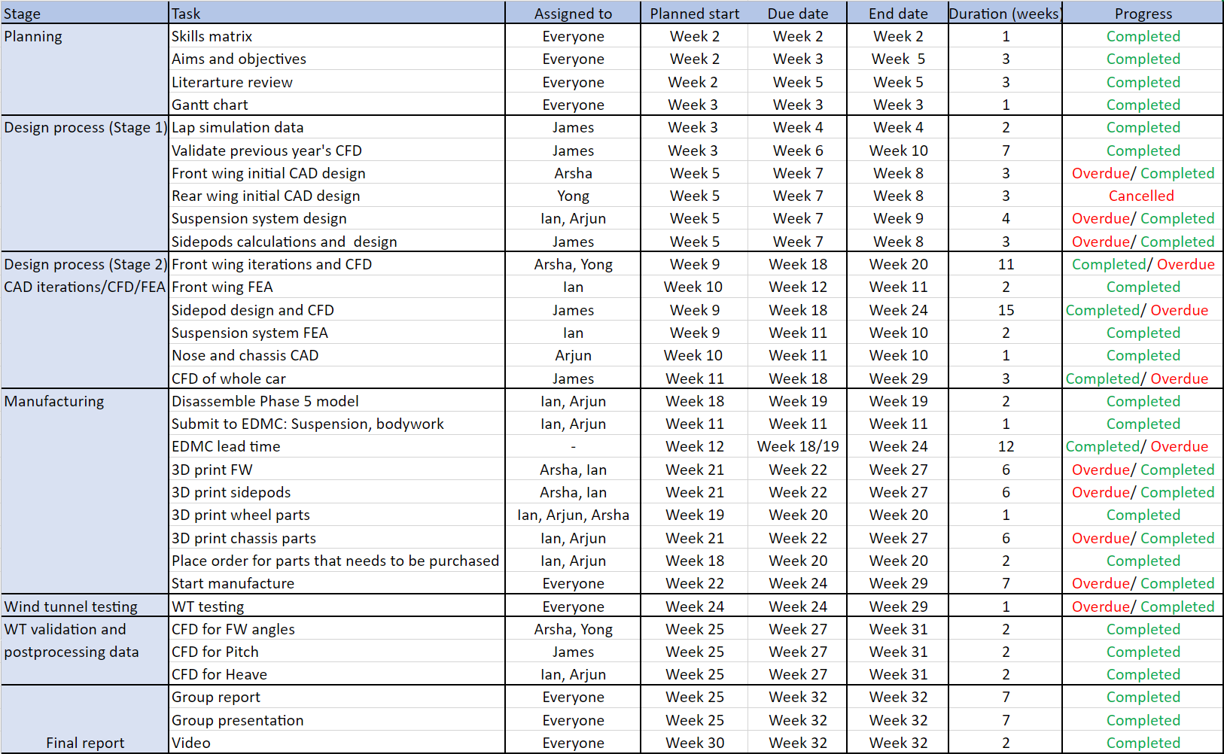

Roles Breakdown

